Master’s thesis



Risk by Design
Internal Asset Partitioning in Dutch Public Company Groups: the live 800-pound gorilla

June 2026

Author: V.H.R. Nap
vincent.nap@student.uva.nl
Under supervision of: prof. R.J. de Weijs
Wordcount: 9,348
Wordcount footnotes: 576

TABLE OF CONTENTS
TABLE OF CONTENTS 2
ABSTRACT 3
PART A – THEORETICAL FRAMEWORK 5
§1: INTRODUCTION 5
§1.1 The problem of partitioning by design 5
§1.2 Method and scope 6
§1.3 Roadmap 6
§2: ASSET PARTITIONING AND CREDITOR PROTECTION 8
§2.1 A brief history 8
§2.1.1 The long road to limited liability 8
§2.1.2 Asset partitioning 9
§2.1.3 Internal asset partitioning 10
§2.2 Observable methods of internal asset partitioning 11
§2.3 Art. 2:403 BW 14
PART B: SCREENING & SELECTION 17
§3: METHODOLOGY 17
§3.1 Screening 17
§3.2 Population and freeze 18
§3.3 Overview of the screening process 18
§3.4 Screening results 20
§3.5 Case selection: Ahold Delhaize and Shell 23
PART C: CASE STUDIES AND RESULTS 25
§4: CASE STUDIES 25
§4.1 Case Study – Ahold Delhaize 25
§4.1.1 Vertical layering (M1) 25
§4.1.2 Horizontal fragmentation (M2) 27
§4.1.3 Finance subsidiary / structural subordination (M3) 29
§4.1.4 Selective perforation (M4) 30
§4.1.5 The 403-declaration (M5) 30
§4.1.6 IP-holding (M6) 31
§4.1.7 Property-holding (M7) 32
§4.1.8 SPV / off-balance vehicles (M8) 33
§4.1.9 Conclusion 33
§4.2 Case study – Shell plc 34
§4.2.1 Vertical layering (M1) 34
§4.2.2 Horizontal fragmentation (M2) 36
§4.2.3 Finance subsidiary / structural subordination (M3) 36
§4.2.4 Selective perforation (M4) 37
§4.2.5 The 403-declaration (M5) 37
§4.2.6 IP-holding (M6) 38
§4.2.7 Property-holding (M7) 38
§4.2.8 SPV / off-balance vehicles (M8) 38
§4.2.9 Conclusion 39
§5: CONCLUSIONS 40
§5.1 Theoretical foundation and analytical frame 40
§5.2 Case study results 40
§5.3 Contribution 41
Bibliography 42
Appendix A – Screening 45
Appendix B – Scoring matrix 53
Appendix C1 – Sources Case Study 55
Appendix C2 – Concernrelaties Ahold Delhaize 57
Appendix C3 – Concernrelaties Shell plc 73

ABSTRACT
Corporate law has enabled firms to grow into the drivers of entire economies. The group structures that result are complex, and each part serves a distinct purpose. Firms routinely use separate legal entities within their groups resulting in large international concerns capable of grossing an entire country’s worth of GDP. Firms of this size affect not only the wider economy but every stakeholder within it, which corporate law intends to regulate. Said regulation isn’t always capable of addressing all consequences, not that we can expect it to. Creditors, sophisticated or not, are most often the ones who fall through the gaps in the law.
Specifically the corporate law feature of separation of legal identity in firms creates asset partitioning, a well-known feature in modern firms and a widely researched concept. By distributing assets strategically across legal entities within a single economic firm, boundaries between pools of assets can be drawn, more commonly known as internal asset partitioning (hereafter: IAP). Creditors are then limited in their recourse to the pool of assets they have a claim on, specifically unsecured creditors draw the short straw.
Most firms exist long enough before insolvency proceedings to warrant the question: can’t we see this coming from miles away? Doctrinal literature by and large focusses either on the theoretical constructs of asset partitioning, or on the harm that results from it. Firms are most often evaluated only in hindsight, typically at or after the end of their lifespan, which is logical because that is when they are most exposed. Little research is conducted pre-emptively about group structures in terms of internal asset partitioning. This thesis sets out to address that gap.
By conducting a thorough analysis of the development of internal asset partitioning, eight publicly observable methods of internal asset partitioning are derived from doctrinal literature. These methods are operationalised in screening twenty-nine firms, the population of the AEX-index, in order to identify signals and indications for internal asset partitioning which were subsequently scored across a matrix. Systematically, mainly annual reports and press releases of subject firms were analysed and indications scored against the matrix. The scores of all twenty-nine firms were aggregated resulting in the selection of Ahold Delhaize and Shell plc for a case study. In this case study, Ahold Delhaize and Shell became subject of a deeper analysis of its annual reports across a five-year window and public registries in order to identify distinctive indication of the eight methods of internal asset partitioning being applied, live. The results from the screening and subsequent findings of the case study showed that the matrix was capable of selecting a firm in which distinctive indications of internal asset partitioning could be found. The case study proved that theoretically rooted methods of internal asset partitioning are present and identifiable in an operating publicly listed firm, making a tangible connection between the theory of internal asset partitioning and its use in practice.

PART A – THEORETICAL FRAMEWORK

§1: INTRODUCTION

§1.1 The problem of partitioning by design
A modern listed firm rarely operates as a single legal entity; firms differ only in how complex their group structure is. It consists of a constellation of parent companies, intermediate holding vehicles, finance subsidiaries, special purpose vehicles, and operating entities spread across multiple jurisdictions, each with its own separate legal personality and a pool of assets available to its creditors. The architecture of the corporate group is not accidental. It is designed. The design of a corporate group determines many things, from capital efficiency to governance and control. Importantly, it also determines who bears what risk. Foundational theory observes a specific functional purpose to this design in firms: asset partitioning.
Drawing legal boundaries by dividing the economic firm into separate entities has as its consequence either external or internal asset partitioning as a function of property law rather than something contracted. Internal asset partitioning (hereafter: IAP) allows for firms to disperse assets across various separate entities that remain part of the economic firm itself. While (internal) asset partitioning is decidedly a function of property law and carries many benefits for large firms, it also comes with clear downsides. Specifically, the limitation of creditor recovery by separation of asset pools is well-discussed in terms of the consequences it has for creditors. By fragmenting an economic firm into many separate legal entities with their own asset pools, creditors are limited in their recovery to the pool of assets of their specific debtor entity, not the firm as a whole. After all, legally they have a claim only on that entity. The theoretical literature demonstrates that and how asset partitioning harms creditors, but there is notably little work connecting the two: applying the widely discussed theoretical framework in order to find what place IAP takes within structures and activities of publicly listed firms.
This thesis distils theoretical methods of IAP from literature and looks for them in practice. By screening a sample of companies based on factors that increase the likelihood and opportunity for IAP to happen, two case studies are selected. Through public disclosure, the methods of IAP are then signalled throughout in order to identify if and how these methods are being applied in a live listed firm.

§1.2 Method and scope
Initially academic literature was consulted in order to trace the development of asset partitioning as a concept, and to end up with the eight methods of IAP. The eight methods found are vertical layering, horizontal fragmentation, use of finance subsidiaries, selective perforation, use of article 2:403 BW, presence of IP-holding companies and property-holding companies and presence of SPVs. Then, a sample of companies was selected. The study chose the AEX index due to the inherent complexities of the companies listed on the specific index, and their Dutch roots. From the literature review in §2, specific publicly observable methods of IAP are identified that constitute part of the screening protocol set out in §3 in order to identify the case study. Each firm was superficially ‘screened’ in order to identify a score that tells the study something regarding the likelihood and opportunity for IAP to happen. After a firm meets a set of threshold requirements, it would then be investigated how complex its structure is, if immediate signals of IAP methods can be found in public disclosure, how much public disclosure is available, and what creditor-classes are present. The observations made from the data are sorted into categories of criteria for an IAP environment defined in §2, from which the highest scoring eligible two firms are selected for a case study.
The case study examines the firms’ financials over a five-year period, together with information too thorough to be reached during screening. This case study has as its purpose to identify IAP methods happening live. It should be emphasised that these do not carry the same connotation as ‘harmful asset partitioning’ identified post-insolvency because we are dealing with considerably healthy firms situated at the top of the food chain. Thus, specific actions or structures are inherently not problematic (yet) because we find ourselves in different conceptual stages of the firm, these partitioning methods are therefore considered to carry the potential of harmful effect for creditors but inferring that they directly cause creditor harm would be speculation and outside the scope of this thesis. But it is necessary to wonder why firms feel the need to have 96 subsidiaries in a single jurisdiction.

§1.3 Roadmap
The study is divided up into 3 parts. Each with their own respective chapters. Part A focusses on drawing the main theoretical framework used as a foundation for the methodology and the case study. Part B applies said framework into a methodology and sets out how firms were screened and what selection for the two case studies followed based on the results. Part C consolidates the picture by discussing the results of the case studies.

§2: ASSET PARTITIONING AND CREDITOR PROTECTION

§2.1 A brief history
A working definition of IAP requires an account of where the concept comes from and what problem it was introduced to solve. Section 2.1.1 follows the corporate form itself, separating the old technique of entity shielding from the much later, statutory arrival of limited liability. Section 2.1.2 then turns to that literature and reconstructs asset partitioning as a functional concept, from its origin in the law of trusts to the internal–external distinction on which this thesis is built. Section 2.1.3 then elaborates on internal asset partitioning.

§2.1.1 The long road to limited liability
The techniques that asset-partitioning theory describes are considerably older than the theory itself. The first to emerge was entity shielding: the protection of a firm’s assets from the personal creditors of its owners, coupled with a priority for the firm’s own creditors over those assets. Rudimentary forms are visible already in Roman commerce, specifically the societas publicanorum “featured forms of asset partitioning…”. But, while these organisations exhibit criteria necessary to consider them asset partitioning, there is no evidence that they were used specifically to organise large business ventures. The early and decisive step was the chartering of the Verenigde Oostindische Compagnie (VOC) in 1602: the first enterprise to issue freely transferable shares against a capital that was progressively locked in for the life of the company which is commonly regarded as the ancestor of the naamloze vennootschap.
What these early forms supplied was entity shielding, not limited liability. Owner shielding, which is the protection of the owner’s personal assets from the firm’s creditors, arrived much later, and by statute instead of nature. In England the modern sequence comes from the Joint Stock Companies Act 1844, which permitted incorporation by simple registration but withheld limited liability, through the Limited Liability Act 1855, which first made it generally available, to the consolidating Companies Act 1862. The principle was sealed judicially in Salomon v A Salomon & Co Ltd, where the House of Lords held that a duly registered company is a legal person distinct from its members, so that neither the controller’s motives nor his complete domination of the company defeated its separate personality or his limited liability. The Dutch line reached the same destination by codification: the naamloze vennootschap was placed on a statutory footing in the Wetboek van Koophandel of 1838, and the separate legal personality of every NV and BV today is a matter of Book 2 BW.
Entity shielding is old and, for a trading entity, close to something that persists naturally as a consequence of organisation; limited liability is a comparatively recent, deliberate, and statutory addition.

§2.1.2 Asset partitioning
The modern concept was started not in company law but in the law of trusts. Hansmann and Mattei argued that the distinctive contribution of trust law is its capacity to partition assets into bundles that can be pledged separately to different classes of creditors, and that because this effect operates against third parties, effectively achieving property-law function. In subsequent works this insight was generalised to organisational law at large. On the account of Hansmann & Kraakman, asset partitioning has two components: “the designation of a separate pool of assets that are associated with the firm, and that are distinct from the personal assets of the firm’s owners and managers”, and “the assignment to creditors of priorities in the distinct pools of assets that result from the formation of a legal entity”. Because that priority operates against creditors who are not party to any bargain, asset partitioning is a function of property law rather than of contract.
The concept revolves around two directions of protection. Entity shielding (affirmative partitioning) protects the firm’s assets from the personal creditors of its owners; owner shielding (defensive partitioning, also known as limited liability) protects the owners’ personal assets from the firm’s creditors. Hansmann, Kraakman and Squire gave the former its now-standard name and argued that it, rather than the more celebrated limited liability, is the legally essential function. Owner shielding can be recreated through contract, whereas entity shielding cannot. It is that same reason why it required law and why it appeared first in history.
The refinement that frames the present study is Hansmann and Squire’s distinction between external and internal partitioning. External partitioning sets the boundary between the firm and its ultimate owners; internal partitioning sets boundaries among the entities of a single corporate group. Their conclusion is that IAP tends to yield smaller efficiency gains and to impose larger costs on creditors than external partitioning, which then begs the question why firms engage in such structures in the first place. While this study cannot speak to the why, it can speak to the how.
A final qualification matters for what follows: partitions are engineered. Assets are placed in distinct entities to tailor financing and capital structure, not merely to cap liability, and the boundaries so created are routinely overridden from within through cross-guarantees and cross-defaults that allow selected creditors to reach across entity lines. The scale is considerable: in 2010 the hundred largest United States public companies by revenue held, on average, 245 major subsidiaries, with a median of 114. All boundaries they then breach selectively through intragroup guarantees in what is termed as correlation-seeking. Thus, legal personality is better understood as a “semi-permeable membrane” than as a wall, so that the strength of any given partition is a product of the firm’s policy choices rather than a logical consequence of incorporation.

§2.1.3 Internal asset partitioning
IAP defines the lines within the firm itself. A listed group is one economic enterprise spread across many legal persons, and it is the boundaries between those persons, not the boundary between the group and its shareholders, that decide which assets a given creditor can reach. Three features are settled in the literature. It concerns creditor recovery, because it sorts which assets answer to which creditors. It operates within one economic firm, not between the firm and its owners. And it can be produced by the ordinary interaction of separate legal persons, each owning its own assets and carrying its own creditors, so that no single instrument creates it on its own.
This thesis defines IAP by that effect, not by any motive behind it which is termed as artificial asset partitioning. Artificial asset partitioning happens specifically when structural choices are made with an eye toward insolvency, designed to extract value from the creditors of the separate legal entities. But whether a structure was chosen to compartmentalise risk, to lower financing costs, or for reasons that have nothing to do with creditors cannot be read from a public filing. The study therefore focusses on consequence and leaves the question of intent.

§2.2 Observable methods of internal asset partitioning
IAP was defined as the separation of pools of assets among distinct legal entities within a single economic firm, capable of limiting creditor recovery. IAP happens in various ways, the following methods (dubbed M1-8) can be derived from asset partitioning literature.
M1 – Vertical layering: firms apply multi-tier holding structures where intermediate entities are situated between listed parents and operating subsidiaries. Those tiers of entities create separate pools of assets and creditors. In doctrinal literature the extent of layering is referred to as either finer or coarser asset partitioning, where the former indicates that assets under common control are dispersed amongst a great number of independent entities, and the latter indicates distribution across a smaller number of entities. Vertical layering is often observable from IFRS 12 disclosures of interests in subsidiaries, KvK Handelsregister extracts and other data points in Annual Reports.
M2 – Horizontal fragmentation: firms expand horizontally, not just vertically. Firms set up multiple subsidiaries in the same layer where business activities are distributed across sibling entities within a group so that operational risks borne by one entity do not have to reach the assets of the others, further fragmenting the recovery pool. Creditors are thus forced to pierce horizontally to reach the assets of other members.
Horizontal fragmentation is generally observable from group subsidiary lists, IFRS 8 operating-segment disclosures cross-referenced against legal-entity structures, and KvK concernrelaties.
M3 – Finance subsidiary, structural subordination: describes the use of subsidiaries whose only assets are equity stakes in their operating subsidiaries. These subsidiaries issue bonds and their only assets are often equity stakes in their siblings or subsidiaries. Bondholders of the finance subsidiary become structurally subordinated: operating subsidiary creditors get paid out first from its assets, if there is anything left over it flows up to the finance subsidiary as residual equity for which they compete. An example for which is disclosed in Aegon Ltd.’s annual report of 2024 under “Cash Capital at Holding and liquidity management”. While not doctrinally recognised explicitly as a partitioning device, Hansmann & Kraakman recognise the use of subsidiaries that specifically hold projects and borrow against them with the parent shielded from debt obligations, effect being that creditors holding claims against higher tier entities (in this case bonds) are effectively structurally subordinated behind operating subsidiary creditors. Considering the effect and that the initial screening confirmed that multiple firms exhibit indications of these structures, it is included as a method of IAP.
Indications and explicit references can be found in EMTN guarantor lists, bond indentures, and annual reports.
M4 – Selective perforation: a guarantee by which one group company takes on liability for another company’s debt to a chosen creditor or class. The guarantee reaches across the partition: the guaranteed creditor can look to the guarantor’s assets, while the creditors left behind compete for less. The applicable rules run, against intuition, in favour of the financial creditors who hold the guarantees, and they reward selective payment to those creditors on the eve of bankruptcy. Under the Dutch rules on double proof the guaranteed creditor can even claim in full against each estate when several group companies fail, which deepens that dilution. The two systems then diverge from one another. In the United States cross-guarantees tie the entities’ fortunes together, so a group tends to fail as a whole and selective bankruptcy is rare. Dutch law keeps each company legally independent: the financial, personal, economic and organisational ties between group companies do not, on their own, displace that independence, even once the structure has been selectively perforated.
Most data regarding the existence and form of perforation can be derived from EMTN guarantor lists, bond indentures and annual reports.
M5 – 403-declaration: in terms of asset partitioning prima facie a good thing for creditor recovery. By issuing a 403-declaration a parent firm becomes "jointly and severally liable” (hoofdelijk aansprakelijk). In turn, the daughter is not required to publish any annual reports because the mother consolidates it in hers. A creditor has a claim on both the daughter and the mother, at any point after issuance. No bankruptcy or risk of bankruptcy is required. Its absence is therefore recognised as a sign of IAP. However, its presence proves to be a double-edged sword in terms of creditor-recovery and should be addressed more explicitly on a case by case basis.
M6 – IP-holding company: in terms of asset partitioning and creditor recovery it must be noted that copyrights are exempt from bankruptcy ex. art. 21 sub 1 Fw, but trademarks and patents are not and can be seized. However, in literature it is explicitly recognised as an item subject to partitioning, and holdings dedicated to them are the method through which this is achieved. In addition, its presence in the screening results and the case study prove that. For creditors this means an IP-holding structure leaves a visible trail: the migration of valuable intangibles into a separate entity can be detected from outside the firm.
Two public sources make IP-holding structures findable:
- the trademark and patent registers: BOIP and EUIPO for trademarks, the USPTO, EPO and equivalent national offices for patents show which entity legally owns the brands and patents
- IAS 38 and IAS 24 disclosures reveal the intangibles carried on the balance sheet and the intra-group licences through which the operating companies pay to use them.
M7 – Property-holding company: works in the same manner as an IP-holding company, except property is an item not exempt from the trustee’s reach in bankruptcy. Both M6 and M7 are valuable assets that can be strategically allocated across various entities for various reasons. Accordingly, both are recognised as methods of (internal) asset partitioning in literature. Property-holding can be identified by their designation in KvK concernrelaties documentation and cross-referencing those subsidiaries with annual report notes and disclosures.
M8 – SPV / off-balance vehicles: receivables, typically mortgages, trade receivables, or lease receivables are transferred by true sale to a bankruptcy-remote special purpose vehicle, removing them from the originator’s estate so they are dedicated exclusively to the SPV’s noteholders. IFRS 12 disclosures on structured entities and the prospectuses of ABS or covered-bond programmes allow a researcher to identify both the existence of these vehicles and get a picture of the kinds of assets they hold.
The nature of these arrangements, and their direct effect on the recovery pool available to Dutch trade, employment, and tort creditors of the originator, lends them to use as indicators in the screening process and as starting points for the following case study.

§2.3 Art. 2:403 BW
One may wonder why art. 2:403 BW deserves its very own section, especially with respect to IAP. Its relation is scarcely covered explicitly in Dutch literature, but it has a noteworthy impact.
By issuing an art. 2:403 BW declaration, the parent becomes jointly and severally liable for its daughter. The idea was great. The parent firm trades administrative burdens – that being having each subsidiary publish annual reports – for liability. The parent issues the declaration once, and then every year the daughters must issue ‘consent declarations’, consenting to the joint and several liability. The declaration does not get ‘refreshed’; the consent declaration has to be issued yearly ex. art. 2:403 lid 1 sub b BW. Creditors of the daughter then have a claim on its mother next to the originating claim, which can be incurred at any time: the 403 takes effect as soon as it is issued. Art. 2:403 BW reaches only uit rechtshandelingen voortvloeiende schulden, leaving obligations arising from the law as opposed to from contract, such as tort claims and regulatory penalties outside its scope. ‘Hoofdelijkheid’ attaches only to debts arising after deposit. A withdrawal under art. 2:404 BW leaves a residual liability for debts already existing from the period in which the declaration was in effect. That residual is itself terminable on a broken relationship to the group, a two-month announcement at the register, a press announcement, and the absence of successful verzet. Finally and vitally, the Supreme Court settled in Akzo Nobel/ING that the reach of the claim is governed by the text of the gedeponeerde verklaring, not by the statute itself. A parent may narrow categories of covered debt, restrict temporal scope, or limit which entities the verklaring covers, and what the text says prevails. The logic behind joint and several liability is, as previously discussed that the creditors are ‘compensated’ with an extra claim on the mother due to a lack of insight in the financial position of the daughter. This becomes more relevant in terms of what is considered ‘public’ and becomes even more important in terms of HR Akzo Nobel/ING. In that case, it was determined that a 403 is not an unconditional claim against the parent, but that the claim and material scope of it depends on the text of the 403 in question. However, when someone would like to assess the contents of this declaration, they must pay €17.95. That calls into question how ‘public’ a 403 really is.
Prima facie, the 403-declaration may seem an elegant solution to the creditor-recovery problems that asset partitioning creates: it gives the subsidiary's creditors a direct claim on the parent. However, after further investigation one must conclude that it does not work as straightforward as that in practice.
The parent may withdraw the declaration at any time by filing a statement to that effect with the trade register (art. 2:404 lid 1 BW). Withdrawal operates only for the future: it ends the parent's liability for debts arising from the subsidiary's legal acts performed after the withdrawal. For debts that already exist, a residual liability (overblijvende aansprakelijkheid) survives the withdrawal (art. 2:404 lid 2 BW).
Ending that residual liability is harder, and not up to the parent alone. Three conditions must be met cumulatively: the subsidiary must no longer belong to the group, a notice of the intended termination must have lain for inspection at the trade register for at least two months, and that intention must have been announced in a national newspaper (art. 2:404 lid 3 BW). Within that period any creditor whose claim is still covered may oppose the termination before the court (verzet); the court upholds the opposition unless the parent provides security for the claim (art. 2:404 lid 4 and 5 BW).
One matter should not be confused with this. The subsidiary's exemption from publishing its own accounts rests on a consent that is renewed each year; if that consent lapses, the exemption falls away and the subsidiary must file its own accounts again. That ends the exemption, not the parent's liability, which runs until it is withdrawn and terminated under art. 2:404 BW.
Between the termination constraints and a recourse limited to whatever the declaration unilaterally covers, even at its best the 403-declaration is not a creditor-protection mechanism but a selective one. Rather, it must be seen as a creditor-reallocation mechanism with predictable losers: tort victims, tax authorities, parent bondholders, and any other creditor group not covered. It is simply too malleable a mechanism to be unconditionally 'good' for creditor recovery. Therefore, its presence cannot be considered as improving the condition of creditors within the methodology of this thesis.

PART B: SCREENING & SELECTION

§3: METHODOLOGY

§3.1 Screening
This chapter sets out the methodology of the screening work that supports the central hypothesis of this thesis. The protocol, described in §3.2 and §3.3, was applied to the AEX-listed cohort to identify the firms most suitable for in-depth case study. It measures one thing: whether the potential for IAP exists. It does not claim to prove IAP from a single pass over twenty-nine annual reports. The AEX was chosen because the probability of encountering complex group structures rises sharply with equity market value. Screening analyses the vertical and horizontal structure of groups, the number of entities, its debt programmes, and screens its annual accounts for any signs of internal asset partitioning, such as vertical layering, selective perforation, large intra-group guarantees, special vehicles, etc. Previously we defined methods of IAP, this chapter operationalises them into a composite indicator. Every score recorded in Appendix B traces to a source logged in Appendix A.
The present research design is doctrinal–empirical: Chapter 2 derives, from the existing primary and secondary literature, a working definition of internal asset partitioning and eight observable methods; Chapter 3 operationalises those methods into a screening protocol; Chapter 4 applies that protocol first to a cohort and then to a single in-depth case. The screening rubric in §3.3 is, methodologically speaking, a composite indicator as described by OECD/JRC Handbook, drawing inspiration from the BAP and AHP composites. This methodology was chosen because (1) the case selection needs to be defensible, and (2) in order to operationalise the theoretical framework constructed in Chapter 2. It also allows for reproducible studies to take place.
All results were compressed into scores. These scores were kept in Appendix B which records the numerical output given to each firm based on all sources listed in Appendix A.

§3.2 Population and freeze
The population is the set of constituents of the AEX index of Euronext Amsterdam. The composition is reviewed quarterly and events between the reviews can change the composition in the middle of the cycle. That specific consideration is evidenced by the fact that there are currently 29 listed companies, frozen on the 24th of April 2026. It is important to mention that the AEX-index expanded from 25 to 30. It contains 29 at this point in time due to Keurig Dr Pepper Inc.’s acquisition of 96.22% of JDE Peet’s N.V. shares. Per the AEX rulebook, JDE Peet’s no longer meets Euronext’s listing requirements and was removed from the composition, which explains why the population consists of twenty-nine firms rather than thirty. No replacement is made until the next quarterly review.

§3.3 Overview of the screening process
Gates
Firstly, a few minimum requirements were set. These are baselines to ensure that the firm in question meets pre-conditions that the central hypothesis requires. The requirements are cumulative, each firm met them:
- There must be a Dutch-seated entity anywhere in the group, whether a parent, intermediary or subsidiary, a parental statutory seat is not required;
- That Dutch entity has measurable exposure to creditors of any class, think of trade payables, bank facilities, listed debt, contingent liabilities, lease obligations, pension creditors, derivative counterparties, deposit holders (for banks), policyholders (for insurers), or material open tax exposures;
- The firm publishes a (consolidated) annual report and a subsidiary list.
Without a Dutch entity, it becomes irrelevant to evaluate the firm in terms of asset partitioning and creditor protection; the firm does not operate in our jurisdiction of subject. Without creditors of that Dutch entity, the question if those creditors are being harmed by asset partitioning also becomes irrelevant because they have no claim on a subsidiary within the relevant jurisdiction. Without annual reports and subsidiary lists, we simply have nothing to go on.
The scoring matrix in Appendix B allocates one hundred points across four criteria: C1 structural footprint (twenty), C2 partitioning methods (fifty), C3 public observability (fifteen) and C4 creditor-class diversity (fifteen). Each firm is scored out of one hundred points across four criteria. C2 carries the most weight because it measures the construct of interest directly, while C1, C3 and C4 measure enabling conditions. The thesis does not claim the 20/50/15/15 split is uniquely correct, but scoring patterns are consistent with the nature of the firm in question. Firms of which we know are not complex or relatively small in size score lower as opposed to complex international conglomerates. The eight methods M1–M8 are those defined in §2.2. Each is anchored in a designated category of public disclosure, preserving the thesis’s commitment to public traceability. Severity is judged relative to the cohort and is necessarily a matter of academic judgement, so all sources consulted are logged in Appendix A for a second researcher to reproduce or contest.
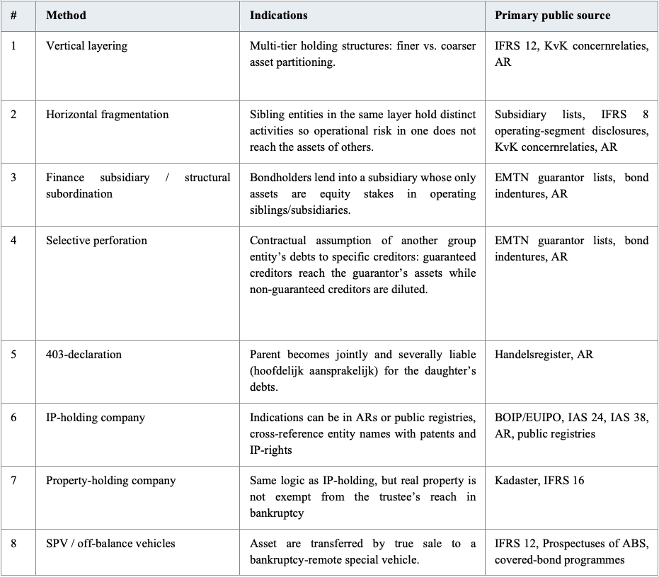
Table 1. Methods.

§3.4 Screening results
Each firm’s total score is the sum of four weighted components: C1 structural footprint (0–20), C2 partitioning methods (0–50), C3 public observability (0–15) and C4 creditor-class diversity (0–15). Table 2 reports these four components and the resulting total. The method-by-method and structural sub-scores behind C2 and C1 are given in Appendix B (Tables B.1–B.2).
Table 2. Summary scores (AEX-29, firms ranked by total score). 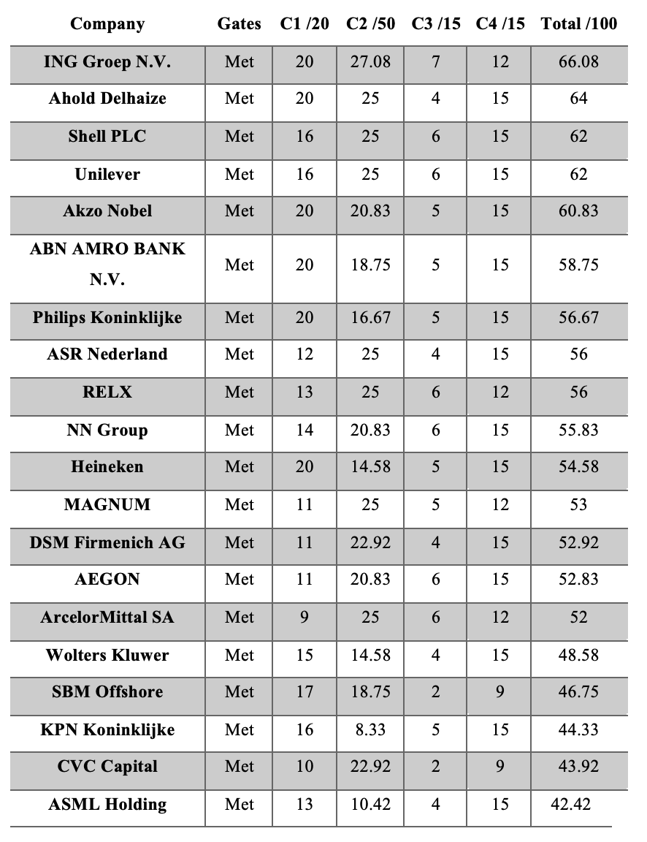
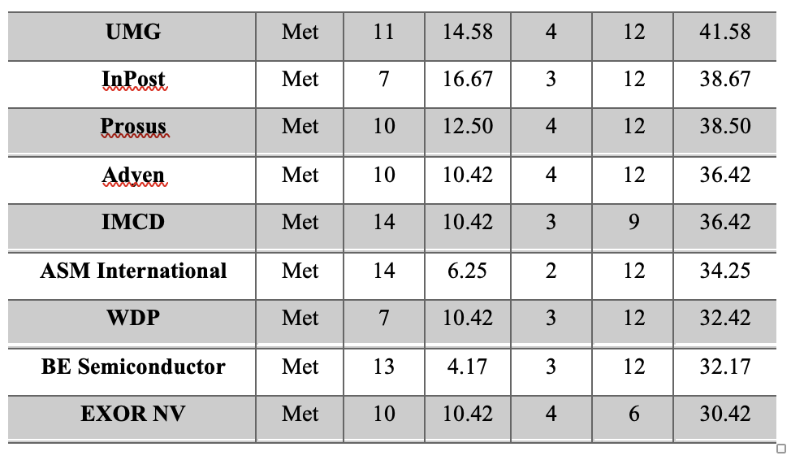
Figure 1 then shows the ‘severity’ of each method found specifically in each firm based on scores gives during screening. The severity ranges based on 0-3 scale and is similarly colour graded accordingly, in order to get an understanding of the severity at a glance.
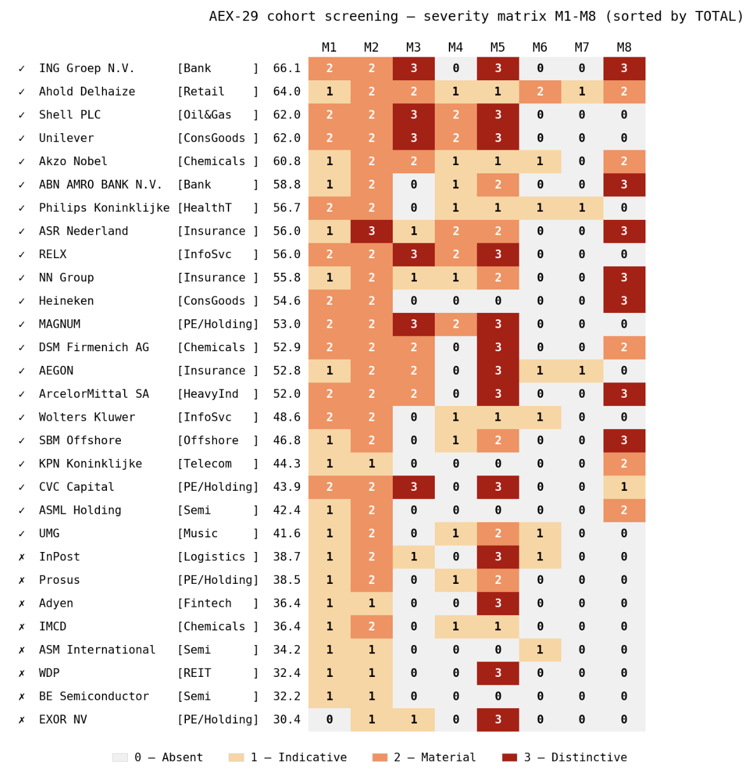
Figure 1. AEX-29 severity matrix (M1–M8), firms ordered by total score
Several patterns stand out. Horizontal fragmentation (M2) is near-universal. IP-holding (M6) and property-holding (M7) show wide white bands — at annual-report-and-web depth they are systematically under-detected and would need commercial-register supplementation to score higher. A relationship between M3 and M5 is visible: firms that show no sign of having issued 403-declarations, and which therefore do not voluntarily collapse partitions, tend instead to build them through finance subsidiaries; the data suggests this rather than establishing it. Below 40 points the structures become simple, as hypothesised, and non-Dutch-parented firms (InPost, EXOR, WDP) score low on both footprint and Dutch-creditor exposure. The financial sector signals strongly on M2, M5 and M8, most plausibly because prudential regulation itself mandates forms of partitioning. Scores reflect annual-report-level evidence; the case study refines individual severities where deeper sources warrant. Figure 2 shows the distribution of each method across the cohort.
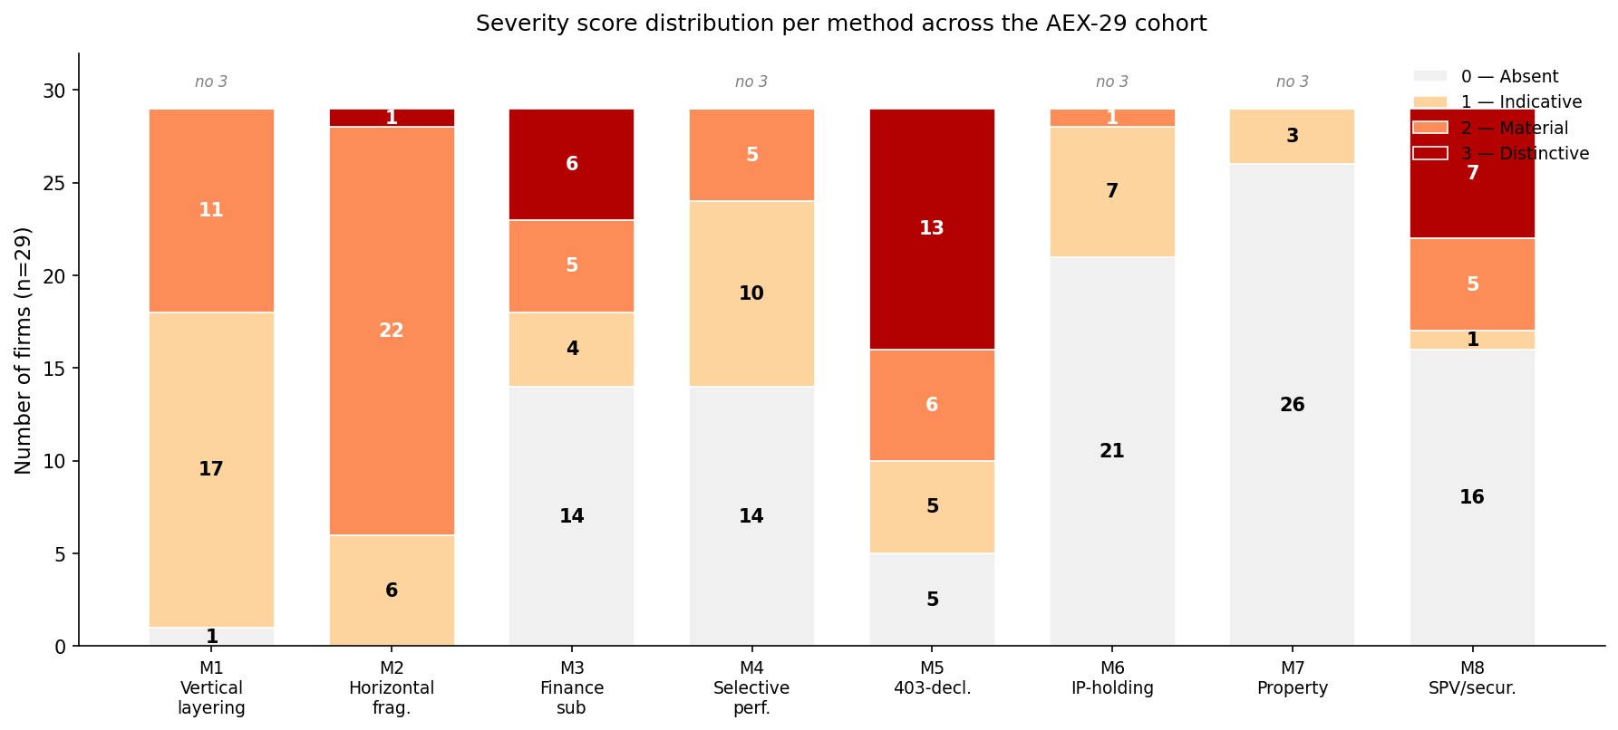

Figure 2. Distribution of severity scores per method across the cohort.

§3.5 Case selection: Ahold Delhaize and Shell
Before selecting two firms based on scoring, two considerations had to be made.
First, the thesis concerns partitioning by design as opposed to partitioning imposed by sector regulation. That consideration removes the top-ranked firm, ING (66.08), and the financial sector generally: as Figure 1 shows, banks and insurers score on M2, M5 and M8 largely because prudential regimes such as BRRD/SRMR and Solvency II compel holding-company and licence-level separation. Their partitioning is real but not freely chosen thus offering a weaker test of the hypothesis.
Second, the chosen cases should between them span the two architectures the screening reveals differences rather than duplicate one another. The M3–M5 relationship marks two poles: firms that collapse the financial partition for their Dutch creditors through broad 403-coverage and issue debt directly, and firms that leave Dutch operating creditors uncovered and instead route financing through guaranteed finance subsidiaries.
Ahold Delhaize (64.00, second overall) is the highest-scoring non-financial, non-regulated firm in the cohort and the cleanest example of the first pole. Its Dutch perimeter is unusually broad. Appendix C2 shows forty-six active 403-covered Dutch entities out of ninety-six in total. It issues its bonds directly from the parent, partitions operationally through horizontal fragmentation using multiple holding vehicles and operating firms. That very same 403-coverage across major subsidiaries enhances and confirms the problems arising from its use in terms of internal asset partitioning and creditor recovery as found in the case study.
Shell (62.00, third overall) is the highest-scoring firm embodying the opposite pole and is selected as the equal second case. Although Shell plc is UK-incorporated, the group retains a Dutch statutory seat and Dutch creditor exposure through Shell Petroleum B.V. and the Dutch finance vehicle Shell International Finance B.V. It is the cohort’s clearest finance-subsidiary case: three finance subsidiaries on-lend roughly USD 77bn of group debt, of which about USD 46bn is parent-guaranteed, producing the structural subordination and selective guarantee pattern that Ahold Delhaize didn’t show, making it a clear second choice for comparison and affirmation.

PART C: CASE STUDIES AND RESULTS

§4: CASE STUDIES

§4.1 Case Study – Ahold Delhaize
Capital structure
At year-end 2025 the group reports total assets of €49,089 million, and the asset side is overwhelmingly operational and intangible. Its single largest category is intangible assets of €13,667 million consisting of €8,363 million of goodwill and €3,353 million of acquired brand names followed by €11,629 million of property, plant and equipment, €9,488 million of right-of-use (lease) assets, €4,794 million of inventories and €3,605 million of cash. Only €259 million is held as investments in joint ventures and associates. Equity attributable to shareholders is €14,195 million, around 29% of the total, so roughly €35 billion is owed to creditors — claims dominated less by funded bonds (loans of about €5.5 billion) than by the operating tier: lease liabilities of some €12 billion under IFRS 16, trade payables of €9,009 million, and provisions of about €1.4 billion (including roughly €1 billion of self-insurance) alongside €504 million of pension obligations.

§4.1.1 Vertical layering (M1)
KAD N.V. is a pure parent holding company. Its balance sheet at year-end 2025 carries only one significant line on the asset side: “Investments in subsidiaries, joint ventures and associates 19,780 (22,194 comparative)”. No inventory, no operating receivables, no PP&E ex-investment-property. Every external creditor of the listed parent would therefore rank behind every operating-tier creditor of every operating subsidiary; see for example the cross-guarantee dated 21 May 2007 with Delhaize Le Lion / De Leeuw NV and Delhaize US Holding, Inc. which has identical wording to the definition of a 403-declaration.
How deep the chain runs depends on which source you consult. Note 35 of the AR supports a more superficial reading: the heading talks of subsidiaries “directly or indirectly owned”, and the US block names five named holding-tier entities below the parent. The KvK extract helps broaden the picture considerably, but it’s convoluted. Most firms are mentioned multiple times in multiple chains in order to elaborate on the relationship to its mother rather than its position in the group. Therefore, we reconstruct two vertical chains more clearly shown in Figure 3.
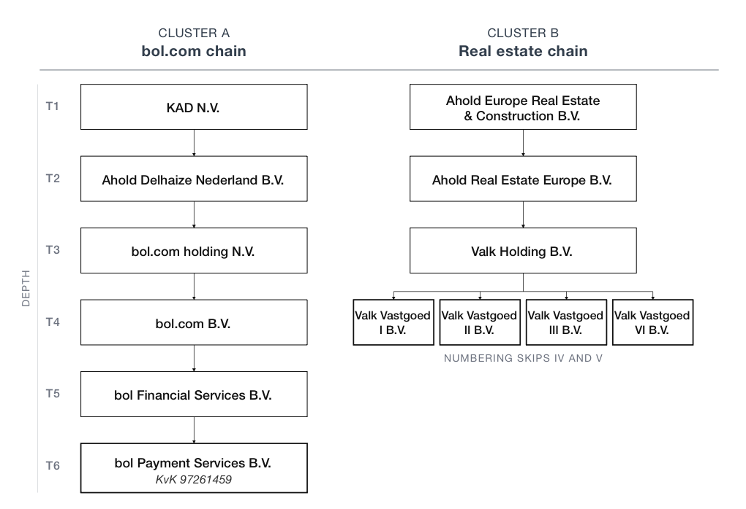
Figure 3. Bol.com depth.
The Note 35 asterisk list discloses eleven Dutch 403-covered entities against the register’s forty-six active 403-covered subsidiaries and ninety-six total active subsidiaries. That amounts to roughly a 24% disclosure of the subsidiaries within active 403 perimeter and about 11% of the active group in total.
The extent of vertical layering evidenced by Appendix C2 is significant. The architecture shows deliberate interposition of multiple Dutch and foreign holding tiers between the listed parent and the operating banners which produces a recovery position for the parent’s general creditors that ranks behind every operating-tier creditor of every operating subsidiary. Furthermore, the ARs disclose a “significant subsidiary” scope which drastically understates the actual depth.

§4.1.2 Horizontal fragmentation (M2)
M1 partitions vertically; M2 fragments horizontally. The group runs ten European banner entities, plus five US banner LLCs, across eight sovereign jurisdictions and seven US sub-state jurisdictions. In addition, the Dutch perimeter also shows significant fragmentation across subsidiaries. Underneath Ahold Delhaize Nederland B.V. we can observe a remarkably long horizontal string of firms: it either fully owns and/or controls 26 siblings at the same level of the structure as shown by Figure 4.
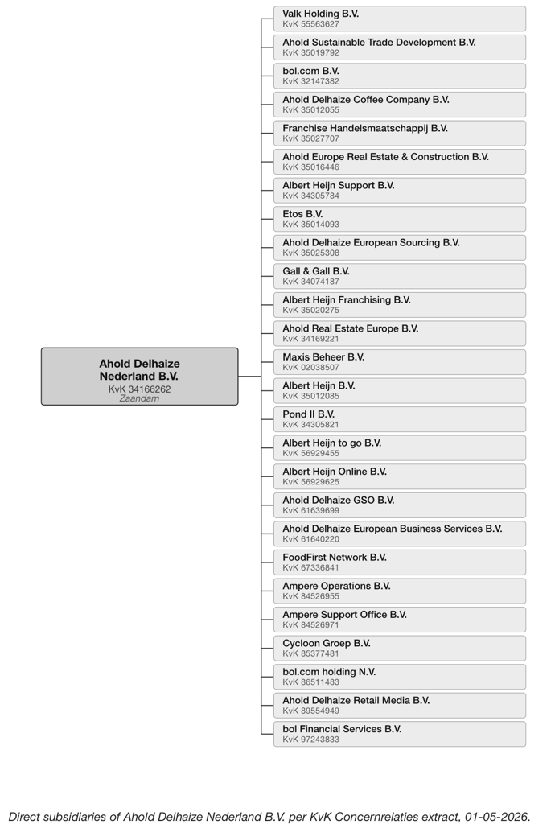
Figure 4. Horizontal fragmentation

AD’s operating segments are “its retail operating companies that engage in business activities… certain operating segments with similar economic characteristics have been aggregated”, according to its ARs. AD manages fifteen operating segments and reports two. Reportable segments under IFRS 8 are then compressed to two: ‘The United States’ and ‘Europe’. For a Dutch creditor the recovery picture is governed by which entity holds its contract, not by which segment that entity reports into or by the listed parent. The 403 declaration drags the parent in for the forty-six Dutch B.V./N.V. entities covered, but not for the foreign equivalents — Albert Heijn België, Delhaize Le Lion, Alfa-Beta, Mega Image, Profi Rom Food, Albert ČR.
This architecture is therefore considered IAP by horizontal fragmentation, operating on two planes: by brand across jurisdictions, and by function within Dutch brands.

§4.1.3 Finance subsidiary / structural subordination (M3)
As far as bonds are concerned, AD is a direct issuer as the parent. Every announcement in the ARs names the parent: “On March 3, 2025, Ahold Delhaize announced that it successfully launched and priced a €500 million eight-year sustainability-linked bond”. The €1.6bn multi-tranche of March 2024 reads the same. Note 22’s boilerplate every year reads “either issued by or guaranteed by Ahold Delhaize, unless otherwise noted”. At year-end 2025 guaranteed total amounted to about €5.5 billion. The effect on external bondholders is straightforward: their first-line obligor is KAD N.V., whose balance sheet is mainly equity stakes in its own operating subsidiaries. Bondholders’ practical recovery position therefore depends on dividend distributions from those operating subsidiaries, flowing through the Dutch and foreign holding chains to the parent.
AD therefore evidences M3 in substance rather than in form: there is no dedicated finance subsidiary, but the parent's overwhelmingly equity-based balance sheet places external bondholders structurally behind or next to every operating-tier creditor. The mechanic is internal asset partitioning as a consequence of financing policy on the parent level rather than through interposed entities.

§4.1.4 Selective perforation (M4)
AD does disclose an extensive selective-guarantee landscape in Note 34 of every AR. At year-end 2025:
Table 3. Selective guarantees Ahold Delhaize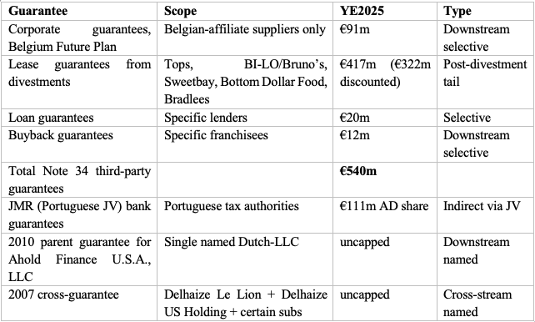
The selective-guarantee architecture must therefore be identified as internal asset partitioning: some named-entity creditors gain a contingent claim against the parent; most do not. The practical effect is, however, limited. The €540m Note 34 total against AD’s roughly €21bn balance sheet is approximately 2.5%, and the largest line (€417m in lease guarantees) is a historical post-divestment residual that is decaying year on year. The uncapped 2010 AFUSA and 2007 cross-guarantees are doctrinally significant because they are explicit and named but unbounded in amount, yet practically insignificant in comparison to the group’s total wealth. Selective perforation exists, but at scales that leave the partitioning with more analytical than recovery significance for most creditor classes.

§4.1.5 The 403-declaration (M5)
The 403-declaration is the statutory mechanism through which a creditor can reach the issuer. Its presence is therefore itself a signal that the underlying architecture is partitioned; the parent has un-partitioned it for specific sub-creditor classes.
This relationship, however, interacts uncomfortably with the parent’s balance sheet. KAD N.V.’s balance sheet shows €19,780m in “Investments in subsidiaries, joint ventures and associates” at YE2025 against essentially no operating revenue assets. For a 403-covered sub creditor invoking the 403, the parent’s own and only asset pool is overwhelmingly equity stakes in the very subsidiaries it has guaranteed. A 403-call could theoretically require the parent to satisfy the claim from cash flows which have to originate from dividend distributions out of the operating daughters making the 403 structurally circular.

§4.1.6 IP-holding (M6)
Two named licensing entities sit in Note 35 every year: Ahold Delhaize Licensing Sàrl (Geneva, 100%) and Guiding Stars Licensing Company, LLC (Scarborough, Maine, 100%). Two further Geneva entities can be found without functional disclosure: Ahold Delhaize International Sàrl and Readel S.A. Public-register and trademark-database research clarifies what each does.
The Swiss commercial register records Licensing Sàrl’s purpose as “leasing of intellectual property and similar products, except copyrighted works”; trademark databases attribute several hundred trademarks to the entity, including the master AHOLD DELHAIZE mark and the GIANT, AH, and other brand-level marks. This is a scaled cross-border IP-holding vehicle and is in terms of IAP a significant finding.
Guiding Stars Licensing Company, LLC holds patents at USPTO + Canadian Intellectual Property Office. The patentable IP is held in a single-state LLC separate from the operating banners. These entities contain goodwill of €8,363m and brand names of €3,353m at year-end 2025, compared to €7,641m and €3,280m at year-end 2021. AD accounting policy considers retail brands “protected by trademarks that are renewable indefinitely”.
The intangibles that are ultimately the ones income-producing are legally owned by Swiss or Maine entities, licensed to operating banners that bear operating exposure. The case study additionally observed absence of royalty income/expense disclosure across all five ARs. It’s construed as a feature by design, not a gap. The IP architecture is therefore internal asset partitioning. Not only are certain IP items out of creditor reach, one can also observe second-order effects that operate through the royalty cash flows coming out of operating banners to those IP holdings.

§4.1.7 Property-holding (M7)
The AR architecture for property appeared rather lean in the initial screening. Note 35 names one Dutch property entity, Ahold Europe Real Estate & Construction B.V., and one US lease vehicle, Ahold Lease U.S.A., Inc. Investment property at year-end 2025 is €508m, against €9,488m of right-of-use assets which is roughly an 18:1 ratio. AD additionally discloses that there are ‘no significant sale and leaseback transactions’ in each of the five years with the single material exception of the Blackstone $475m triple-net-lease subsequent event..
The KvK register does broaden the picture considerably. Ahold Europe Real Estate & Construction B.V. turns out to be a subsidiary of Ahold Real Estate Europe B.V. as seen in M1, a firm which also hosts Ahold Real Estate Czech Republic B.V. which has its own subsidiary. Furthermore, Appendix C2 extracts at least ten further property-related companies. The register documents a chain of single-purpose vehicles spanning across decades seemingly dedicated to the distribution of property. The Valk Vastgoed I–VIII series (of which V, VII, and VIII are dissolved, leaving I, II, III, and VI active) is a clear example: four sibling single-purpose property B.V.s sitting under a common Valk Holding B.V., each isolated from the others and from the operating banners. It is highly unlikely that all these holdings are empty and passive. This cluster also happens to be the one illustrated in Figure 3 as cluster B in the evaluation of M1, a notable coincidence. The Pond cluster has the same pattern historically: a thirteen-vehicle series of which only Pond II remains active. The Beemster cluster, six entities, is fully dissolved. The fact that these vehicles are also situated in the second deepest cluster M1 analysed is also an interesting observation in terms of IAP; it is only logical that property-holding vehicles appear in deeper tiers of group structures.
The shift from owned property to leased property can compound the effect by moving underlying assets off the consolidated balance sheet altogether, narrowing the asset pool available to operating creditors before any partition argument is reached.

§4.1.8 SPV / off-balance vehicles (M8)
The thesis defines M8 as covering true-sale securitisation, bankruptcy-remote SPVs, and statutorily ring-fenced cover pools. These architectures have a defining mechanic: the extraction of assets from the originator’s general estate and their dedication to a specific creditor class.
However, the honest reading is that there is not enough evidence to conclude that M8 is practiced at AD. The case study cannot distinguish, on the available disclosure, between (a) genuine M8 partitioning hidden in entities that exist in the register but lack functional disclosure in the ARs; (b) semi-debt and creditor class differentiation through trade-finance and risk-financing arrangements that are disclosed but do not by definition meet the asset-extraction test; and (c) a group simply without M8 partitioning, whose intra-group risk financing is not SPV-based. Therefore, it cannot be claimed that M8 shows a distinctive presence in the disclosed and public information of AD.

§4.1.9 Conclusion
Ahold Delhaize is the chosen case in which the asset-partitioning architecture is most clearly operational rather than financial. The seven methods that produced evidence each contribute their own observation. M1 (vertical layering), M2 (horizontal fragmentation), M5 (403-declaration), M6 (IP-holding) and M7 (property-holding) are strongly evidenced on primary-source disclosure. M3 (finance-subsidiary) and M4 (selective perforation) are present but lean in practical effect. M8 falls out of evidence.
Together, the case study proves that the theoretical foundation set out in Chapter 2 can be implemented in a screening methodology that yields a case study. That case study then consistently exhibits seven of the eight methods. The hypothesis that methods of internal asset partitioning as discussed in theory can be found in live, publicly listed Dutch firms, is supported.

§4.2 Case study – Shell plc
Capital structure
At year-end 2025 the group reports total assets of $370,350 million, and the asset side is overwhelmingly physical and capital-intensive. Its single largest category is property, plant and equipment of $185,077 million followed by trade and other receivables of $44,597 million, cash of $30,216 million, intangible assets of $26,672 million (consisting of $15,662 million of goodwill and $11,010 million of other intangibles), and inventories of $22,216 million. A substantial $27,775 million is held as equity-accounted investments in joint ventures and associates. Equity attributable to Shell plc shareholders is $174,392 million, around 47% of the total, so roughly $195 billion is owed to creditors. Claims consisted less of funded bonds than of a deep operating and provisioning tier: funded borrowings of about $46.7 billion (bonds, notes and bank debt), lease liabilities of some $28.9 billion under IFRS 16, trade and other payables of $62,233 million, and decommissioning and other provisions of about $27.3 billion (including roughly $18.8 billion of asset-retirement obligations) alongside $11,983 million of deferred tax and $7,136 million of retirement-benefit obligations (partly offset by $5,052 million of recognised pension surpluses).

§4.2.1 Vertical layering (M1)
The KvK Concernrelaties extract sets out the total concern of Shell Group Holding Limited and shows 160 Dutch-registered entities, with up to roughly eight register tiers. A single ownership chain illustrates the depth as shown in figure 5, confirmed in the parent-company accounts, which reads that “the Company contributed its investment in Shell Petroleum to another subsidiary, Shell Group Holding Limited” against shares issued at a premium of “$257,493 million.”
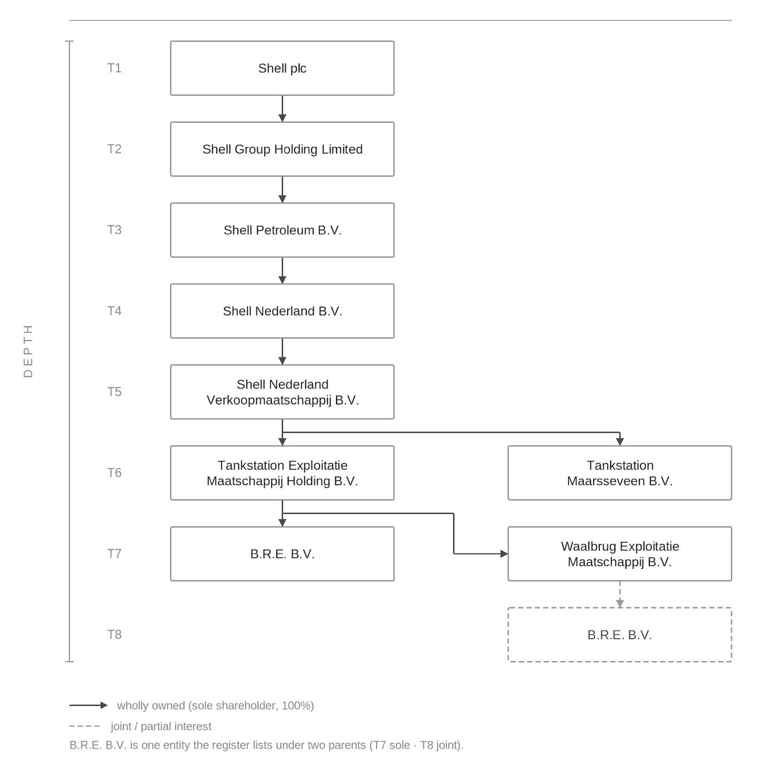
Figure 5. Shell depth.

As with Ahold Delhaize, the disclosure gap runs the other way entirely. Shell’s report carries an “Appendix 1: Significant subsidiaries and other related undertakings (audited)” that names 149 of the 160 register entities; eleven appear in the register alone which is a 93% disclosure rate as opposed to Ahold’s 11%.

§4.2.2 Horizontal fragmentation (M2)
M2 fragments horizontally. At report level Shell runs six reportable segments: Integrated Gas, Upstream, Marketing, Chemicals and Products, Renewables and Energy Solutions, and Corporate. The register shows a finer pattern: each activity and asset is channelled into its own ring-fenced B.V. There is one company per solar site (Solar Power Emmen, Heerenveen, Moerdijk and Sas van Gent-Zuid), one per wind or carbon-capture project (NoordzeeWind, Shell WindEnergy Netherlands, Aramis CCS and Aramis S1), one per function (Raffinaderij at Pernis, Chemie at Moerdijk, Verkoopmaatschappij, Trademark Management, Trading), and a numbered exploration-and-production series. The largest single Dutch upstream interest, the Nederlandse Aardolie Maatschappij B.V. (NAM), is held as a joint venture: “NAM holds a 60% interest in the onshore low-calorific Groningen gas field.”
Fragmentation happens on two planes here, both by function and jurisdiction. A creditor of one ring-fenced unit cannot reach the assets of its siblings. An interesting note is also that the Groningen earthquake liabilities sit inside NAM: the very class not covered by a 403. Thus, horizontal fragmentation is strongly evidenced.

§4.2.3 Finance subsidiary / structural subordination (M3)
Here Shell differs sharply from Ahold Delhaize. Shell’s report is explicit: “The debt issued under the CP, EMTN and US shelf has been issued by Shell International Finance B.V., the issuance company for Shell, with its debt being guaranteed by Shell plc.” The programmes are a “$10 billion global commercial paper (CP) programme,” an “unlimited Euro medium-term note (EMTN) programme” and an “unlimited US universal shelf.” From 2023 a second vehicle was added: “Shell incorporated a new US subsidiary, Shell Finance US Inc.” into which debt has since been migrating, alongside the issuer BG Energy Capital plc.
The parent guarantee of Shell International Finance B.V.’s listed debt stood at “$31,778 million at December 31, 2024 (December 31, 2023: $48,356 million),” with a further $11,443 million guaranteed for Shell Finance US Inc. and $2,825 million for BG Energy Capital plc — approximately $46.0 billion in total. Because the issuers hold intra-group receivables rather than operating assets, their bondholders are structurally subordinated to every operating-company creditor and depend on the Shell plc guarantee for recovery. Unlike Ahold Delhaize, Shell evidences M3 in form as well as substance: finance-subsidiary partitioning is strongly evidenced and is the firm’s defining feature.

§4.2.4 Selective perforation (M4)
Shell’s guarantee architecture is the inverse of a carve-out: the ~$46 billion Shell plc guarantee covers the finance vehicles’ listed debt uniformly and without cap, and the reports disclose no “non-recourse,” “keepwell” or other carve-out language. At consolidated level the obligation is described as remote: “There were no guarantees or other off-balance sheet arrangements … reasonably likely to have a material impact on Shell.” The selectivity is therefore not between entities but between creditor classes: bondholders obtain a direct claim on the UK parent, while operating-trade, employment and involuntary creditors do not. Functionally the guarantee is Shell’s contractual substitute for the 403 declaration its UK parent cannot issue. Selective perforation is present and material, with the same signature of predictable losers among tort and regulatory creditors found in Ahold Delhaize.

§4.2.5 The 403-declaration (M5)
Shell plc is incorporated in England and Wales and cannot issue a 403 declaration, and the reports contain no reference to the regime. The register affirms that reading: an intermediate Dutch holding company, Shell Nederland B.V., has itself filed 403 declarations, but for only four operating subsidiaries — Shell Nederland Raffinaderij B.V. (Pernis), Shell Nederland Chemie B.V. (Moerdijk), Shell Nederland Verkoopmaatschappij B.V. and SHELL Asset Management Company B.V.
The contrast with Ahold Delhaize is exact and instructive. Ahold Delhaize’s declaration is issued by the ultimate parent and reaches forty-six Dutch entities; Shell’s is issued four tiers down and reaches four, leaving the partition between the Dutch sub-group and the UK parent fully intact. Coverage exists, but it is selective and shallow: the creditors of the four covered entities gain a claim only against Shell Nederland B.V., not against the group’s apex. M5 is thus present in a thin, intermediate-holding form — a partition only lightly perforated, and only for the core Dutch operators.

§4.2.6 IP-holding (M6)
Shell maintains, in its own words, “a wide-ranging intellectual property (IP) portfolio which includes patents, trademarks, know-how, trade secrets and copyrights,” including “the distinctive Shell Pecten.” The register and trademark databases locate that value in a dedicated Dutch cluster: Shell Trademark Management B.V. is the registered owner of the Shell word-mark and the Pecten device and holds a portfolio of several hundred marks, sitting beneath SHELL Internationale Research Maatschappij B.V., the group’s research and patent entity. The brand is actively licensed out — the report records 8,030 retail sites “operated through trademark licensing agreements” — so licence income flows to the holding entities and away from the operating companies that bear creditor exposure. Shell’s IP is held onshore in the Netherlands rather than in low-tax vehicles in Geneva and Maine, but in separate holding vehicles.

§4.2.7 Property-holding (M7)
For Shell the method is a demonstrated absence. The reports disclose no sale-and-leaseback transactions and carry no investment property; the group’s substantial real estate — refineries, chemical plants and retail sites — is held at operating-company level rather than in a property holding layer. The only site-related cluster in the register is the Rotterdam “Tankstation” and “Exploitatie” group beneath the sales company, which is operating rather than property-holding in character. In contrast to Ahold Delhaize’s multi-vehicle property structure, property-holding partitioning falls out of the evidence for Shell.

§4.2.8 SPV / off-balance vehicles (M8)
The reports disclose no securitisation, structured-entity, special-purpose-vehicle, supplier-finance or covered-bond programme. The single SPV-adjacent feature is a captive insurance arrangement. Shell “self-insures most of” its risk and discloses amounts “received from a captive structure in relation to pension plans reinsured.” A captive that holds reserves against the group’s own risk does not extract assets from the originator’s estate for the benefit of an external creditor class, so it fails the asset-extraction test, exactly as the captives of Ahold Delhaize did. M8 therefore falls out of evidence as well.

§4.2.9 Conclusion
Shell plc is the financial-partitioning counterpart to Ahold Delhaize. Methods are strongly evidenced on primary-source disclosure: vertical layering (M1), horizontal fragmentation (M2), the finance-subsidiary architecture (M3), selective perforation through the parent guarantee (M4), and selective 403 usage (M5) and IP-holding (M6). All while the property-holding (M7) and the off-balance method (M8) fall out of the evidence as demonstrated absences.
Shell’s architecture channels all external bond debt through asset-poor finance vehicles and then extends a single ~$46 billion parent guarantee to their bondholders, while the involuntary creditors who cannot price-protect: the Groningen claimants held within NAM, and the climate claimants in the Milieudefensie litigation, remain behind the full entity partition. The same instrument logic that the §2.3 critique identifies for the 403 reappears here as a contractual guarantee: it relieves the protected class precisely where protection is least needed.
Internal asset partitioning is, also in a second case, identifiable empirically from a foundation of theory, and in a firm structurally opposite to the first case. Its structure and the nature of the firm itself resonate with the case study results.

§5: CONCLUSIONS

§5.1 Theoretical foundation and analytical frame
This thesis set out from the foundational feature of asset partitioning and its effect on creditor recovery. Asset partitioning is one of the defining functions of organisational law: the legal creation of distinct pools of assets that some creditors can reach and others cannot. A vital line is drawn between external and internal asset partitioning, the concept on which this thesis is built. This thesis then expands the framework by identifying eight publicly observable methods of internal asset partitioning drawn from the theoretical literature and pertaining to the use of corporate structure to partition assets within a single consolidated economic group. Chapter 3’s model which used the theory yielded consistent and explainable results.

§5.2 Case study results
The case studies find internal asset partitioning at a noticeable scale across most of the methods set out in Chapter 2: in each firm, five of the eight methods are strongly evidenced, though not the same five. Vertical layering and horizontal fragmentation come into focus in both once the Dutch trade register is layered on top of annual-report disclosure, which exposed a deeper and more compartmentalised group structure than one would read from the AR alone. The intangible asset holding architecture is confirmed through primary-source trademark and patent registers, which place Ahold Delhaize's brand and patent portfolios with dedicated Swiss and US licensing vehicles, and Shell's with a dedicated Dutch trademark and research cluster in their respective dedicated vehicles. The property-holding architecture surfaces through the same register route at Ahold Delhaize and reveals a long-running pattern of single-purpose property vehicles; at Shell it is absent, the group's real estate being held at operating-company level. The 403-declaration cases also run in opposite directions: comprehensive in form across Ahold Delhaize's Dutch perimeter but bounded on every dimension recognised in the §2.3 critique and structurally circular, whereas at Shell it narrows to four operating subsidiaries declared one tier down by an intermediate Dutch holding company.
Two methods are present but lean in practical effect at Ahold Delhaize, and it is there that Shell delivers a contrast. The finance-subsidiary pattern is only partially found in Ahold Delhaize: there is no operating finance-subsidiary used as bond issuer, but the underlying mechanic of structural subordination arguably still operates, because the parent's balance sheet is overwhelmingly equity in operating subsidiaries. At Shell it is the defining feature, the group's external debt being issued through dedicated finance vehicles guaranteed by the UK parent at a scale of roughly USD 46 billion. The selective-guarantee architecture is, at Ahold Delhaize, real and disclosed but small relative to the group balance sheet, leaving it with more analytical than recovery significance. At Shell that same guarantee carries the group's bond debt and segments creditors by class rather than by entity. The off-balance-vehicle method falls out of evidence in both cases.

§5.3 Contribution
The contributions of the thesis are on the one hand more limited and on the other broader than it might otherwise appear. Limited, because the framework does not claim to cover every legal-architectural pattern a corporate group can deploy, and the eighth method admitted by the literature is not universally evidenced. Broader, because the seven methods that are evidenced are evidenced at scale, in a real firm, on primary-source documentary disclosure that any researcher with KvK access can reproduce. Internal asset partitioning is identifiable empirically from a foundation of theory, and the framework presented here is one workable instrument for identifying it. The doctrinal research provided a workable and repeatable model; its application and subsequent selection yielded a case study that confirmed and expanded on the indications found in the initial screening and found evidence of the theoretical IAP methods in two practical case studies.

Bibliography
Bartman, S. M., Dorresteijn, A. F. M., & Olaerts, M. (2020). Van het concern (10th ed.). Wolters Kluwer.
Belenzon, S., Lee, H., & Patacconi, A. (2023). Managing risk in corporate groups: Limited liability, asset partitioning, and risk compartmentalization. Strategic Management Journal, 44(12), 2888–2921. https://doi.org/10.1002/smj.3531
Blair, M. M. (2003). Locking in capital: What corporate law achieved for business organizers in the nineteenth century. UCLA Law Review, 51, 387–455. https://www.uclalawreview.org/wp-content/uploads/2019/09/22_51UCLALRev3872003-2004.pdf
Casey, A. J. (2015). The new corporate web: Tailored entity partitions and creditors’ selective enforcement. Yale Law Journal, 124(8), 2680–2744. https://www.yalelawjournal.org/article/the-new-corporate-web
de Weijs, R. J. (2018). Secured credit and partial priority: Corporate finance as a creation or an externalisation practice? European Property Law Journal, 7(1), 63–95. https://doi.org/10.1515/eplj-2018-0004
Fleckner, A. M. (2020). Roman business associations. In G. Dari-Mattiacci & D. P. Kehoe (Eds.), Roman law and economics: Institutions and organizations (Vol. I, pp. 233–272). Oxford University Press. https://doi.org/10.1093/oso/9780198787204.003.0009
Gelderblom, O., de Jong, A., & Jonker, J. (2013). The formative years of the modern corporation: The Dutch East India Company VOC, 1602–1623. The Journal of Economic History, 73(4), 1050–1076. https://doi.org/10.1017/S0022050713000879
Gorton, G. B., & Souleles, N. S. (2007). Special purpose vehicles and securitization. In M. Carey & R. M. Stulz (Eds.), The risks of financial institutions (pp. 549–602). University of Chicago Press / NBER. https://www.nber.org/system/files/chapters/c9619/c9619.pdf
Hansmann, H., & Kraakman, R. (2000). The essential role of organizational law. Yale Law Journal, 110(3), 387–440. https://yalelawjournal.org/article/the-essential-role-of-organizational-law
Hansmann, H., Kraakman, R., & Squire, R. (2006). Law and the rise of the firm. Harvard Law Review, 119(5), 1333–1403. https://law.yale.edu/sites/default/files/documents/pdf/Faculty/Hansmann_Law_and_the_Rise_of_the_Firm.pdf
Hansmann, H., Kraakman, R., & Squire, R. (2014). Incomplete organizations: Legal entities and asset partitioning in Roman commerce (ECGI Working Paper Series in Law No. 271/2014). European Corporate Governance Institute.
Hansmann, H., & Mattei, U. (1998). The functions of trust law: A comparative legal and economic analysis. New York University Law Review, 73(2), 434–479. https://www.nyulawreview.org/wp-content/uploads/2018/08/NYULawReview-73-2-Hansmann-Mattei.pdf
Hansmann, H., & Squire, R. (2018). External and internal asset partitioning: Corporations and their subsidiaries. In J. N. Gordon & W.-G. Ringe (Eds.), The Oxford handbook of corporate law and governance. Oxford University Press. https://ssrn.com/abstract=2733862
Iacobucci, E. M., & Triantis, G. G. (2007). Economic and legal boundaries of firms. Virginia Law Review, 93(3), 515–570. https://virginialawreview.org/wp-content/uploads/2020/12/515.pdf
Jonkers, A. L. (2019). Selective perforation by means of guarantees: Dutch law. In R. Squire, J. Vananroye, A. Van Hoe, G. Lindemans, A. Karapetian, F. M. J. Verstijlen, & A. L. Jonkers (Eds.), The 800-Pound Gorilla: Limits to Group Structures and Asset Partitioning in Insolvency (pp. 75–99) (Reports NACIIL / Preadviezen NVRII 2018). Eleven International Publishing.
Karapetian, A., & Verstijlen, F. M. J. (2018). Strategic asset partitioning under Dutch law. In The 800-pound gorilla: Limits to group structures and asset partitioning in insolvency (NACIIL/NVRII Preadviezen 2018, pp. 57–74). Eleven International Publishing. https://nvrii.nl/wp-content/uploads/2021/07/preadviezen-2018.pdf
Lennarts, M. L. (1999). Concernaansprakelijkheid: rechtsvergelijkende en internationaal privaatrechtelijke beschouwingen (Uitgaven vanwege het Instituut voor Ondernemingsrecht nr. 32). Kluwer.
Nardo, M., Saisana, M., Saltelli, A., Tarantola, S., Hoffmann, A., & Giovannini, E. (2008). Handbook on constructing composite indicators: Methodology and user guide. OECD Publishing. https://doi.org/10.1787/9789264043466-en
Pargendler, M. (2024a). The fallacy of complete corporate separateness. Harvard Business Law Review Online, 14(1), 1–17. https://journals.law.harvard.edu/hblr/wp-content/uploads/sites/87/2024/04/01_HLB_14_1_Mariana-Pargendler_Online.pdf
Pargendler, M. (2024b). The new corporate law of corporate groups. Harvard Business Law Review, 14(2), 339–402. https://journals.law.harvard.edu/hblr/wp-content/uploads/sites/87/2024/10/03_HLB_14_2_Mariana-Pargendler.pdf
Reumers, M. L. H. (2007). Samengevoegde afwikkeling van faillissementen [Doctoral dissertation, Erasmus Universiteit Rotterdam]. EUR Repository. https://repub.eur.nl/pub/10780/Reumers%20diss%20compleet.pdf
Squire, R. (2011). Strategic liability in the corporate group. University of Chicago Law Review, 78(2), 605–670. https://ir.lawnet.fordham.edu/cgi/viewcontent.cgi?article=1065&context=faculty_scholarship
Squire, R. (2018). Limits to group structures and asset partitioning in insolvency: Suppressing value and selective perforation by means of guarantees. In The 800-pound gorilla: Limits to group structures and asset partitioning in insolvency (NACIIL/NVRII Preadviezen 2018, pp. 1–20). Eleven International Publishing. https://nvrii.nl/wp-content/uploads/2021/07/preadviezen-2018.pdf
Tijssen, H. E. B. (2009). De juridische dissertatie onder de loep: De verantwoording van methodologische keuzes in juridische dissertaties. Boom Juridische Uitgevers.
Van Dooren, E. A. (2021). De aansprakelijkheid op grond van een 403-verklaring (IVOR Vol. 122). Wolters Kluwer. https://research-portal.uu.nl/ws/files/78970139/de%20aansprakelijkheid%20op%20grond%20van%20een%20403-verklaring%20-%206013cde1ce201.pdf
Vananroye, J., Van Hoe, A., & Lindemans, G. (2018). Curb Your Opportunism: Limits to group structures and asset partitioning in insolvency in belgium. In The 800-pound gorilla: Limits to group structures and asset partitioning in insolvency (NACIIL/NVRII Preadviezen 2018). Eleven International Publishing. https://nvrii.nl/wp-content/uploads/2021/07/preadviezen-2018.pdf

Case law
HR 28 juni 2002, ECLI:NL:HR:2002:AE4663, NJ 2002/447 (Akzo Nobel/ING Bank).
Salomon v A Salomon & Co Ltd [1897] AC 22 (HL).

Appendix A – Screening

Euronext
ID | Date | Document | Source & URL
A000 | 2026-05-10 | Dr Pepper acquisition JDE Peet | https://www.investegate.co.uk/announcement/gnw/jde-peets-nv--0a5i/keurig-dr-pepper-acquires-jde-peet-s-and-ann-/9503479
A001 | 2026-02-07 | AEX index landing page (Euronext Live) | https://live.euronext.com/en/product/indices/NL0000000107-XAMS#index-composition
A002 | 2026-02-07 | AEX index equities listing (Euronext Live) | https://live.euronext.com/en/markets/amsterdam/equities-by-index/aex-index
A003 | 2026-02-07 | AEX Index Family rule-change documentation | https://www.euronext.com/en/about/media/euronext-press-releases/number-constituents-aexr-index-will-increase-30

Cohort screening
ID | Date consulted | Firm | Source & URL
A004 | 2026-04-04 | ABN AMRO | ABN AMRO Bank N.V. Integrated Annual Report 2024
A005 | 2026-04-04 | ABN AMRO | ABN AMRO Bank N.V. Pillar 3 Report 2024
A006 | 2026-04-04 | ABN AMRO | ABN AMRO programme documentation directory page
A007 | 2026-04-04 | ABN AMRO | ABN AMRO Bank N.V. EMTN Securities Note, 15 Aug 2025 (together with RD dated 6 Jun 2025 constitutes the base prospectus)
A008 | 2026-04-04 | Adyen | Adyen N.V. Investor Relations financials landing page
A009 | 2026-04-04 | Adyen | Adyen press release "Adyen publishes 2024 Annual Report" dated 7 March 2025
A010 | 2026-04-04 | Adyen | Adyen H1 2025 press release dated 14 August 2025 (financialreports.eu CDN — primary publication channel)
A011 | 2026-04-04 | Adyen | Adyen N.V. Annual Report 2025
A012 | 2026-04-04 | Adyen | Adyen N.V. Transparency and Disclosure Report 2025 Pillar 3
A013 | 2026-04-04 | Adyen | Adyen N.V. IPO Prospectus
A014 | 2026-04-05 | AEGON | Aegon Ltd. Integrated Annual Report 2024
A015 | 2026-04-05 | AEGON | Aegon press release "Redomiciliation to Bermuda completed"
A016 | 2026-04-05 | Ahold Delhaize | Koninklijke Ahold Delhaize N.V. Financial Statements Annual Report 2024
A017 | 2026-04-05 | MAGNUM (TMICC) | TMICC corporate IR demerger information page (and Unilever demerger page)
A018 | 2026-04-05 | UMG | Universal Music Group N.V. IR landing page and 2025 AR publication press release (26 March 2026)
A019 | 2026-04-06 | Ahold Delhaize | Koninklijke Ahold Delhaize N.V. Integrated Annual Report 2024
A020 | 2026-04-06 | Akzo Nobel | Akzo Nobel N.V. Annual Report 2024
A021 | 2026-04-06 | Akzo Nobel | AkzoNobel Q4/FY2024 Report
A022 | 2026-04-06 | Akzo Nobel | Akzo Nobel N.V. EMTN Base Prospectus dated 18 March 2025 (CSSF-approved, listed Euronext Dublin)
A023 | 2026-04-06 | Akzo Nobel | Aggregated reporting on the Ichthys / INPEX Operations Australia / JKC Australia LNG litigation (Federal Court of Australia, Perth)
A024 | 2026-04-06 | Akzo Nobel | Historical Akzo Nobel AR Note J / Note 20 disclosures (FY2011, FY2018, FY2020)
A025 | 2026-04-07 | ArcelorMittal | ArcelorMittal Form 20-F FY2024 Exhibit 8.1: List of Principal Subsidiaries as of 31 December 2024
A026 | 2026-04-07 | ArcelorMittal | Existence of Dutch B.V. entities in the ArcelorMittal group
A027 | 2026-04-07 | ArcelorMittal | ArcelorMittal SA EMTN Base Prospectus dated 23 May 2025 + Prospectus Supplement No. 1 dated 2 July 2025 (CSSF-approved, Bourse de Luxembourg)
A028 | 2026-04-07 | ArcelorMittal | ArcelorMittal IR EMTN programme history page
A029 | 2026-04-07 | ASM International | ASM IR results centre
A030 | 2026-04-07 | ASM International | ASM International AR 2024
A031 | 2026-04-07 | ASM International | ASM International AR 2025
A032 | 2026-04-07 | ASM International | ASM International AR 2023 (281 pages, IFRS-EU)
A033 | 2026-04-07 | ASM International | ASM International AR 2017
A034 | 2026-04-07 | ASM International | ASMI delisting and SEC deregistration filings (2015)
A035 | 2026-04-07 | ASM International | ASM International AR 2025
A036 | 2026-04-08 | ASML | ASML 2025 Annual Report downloads page (HTML index)
A037 | 2026-04-08 | ASML | ASML 2025 Annual Report based on IFRS-EU
A038 | 2026-04-08 | ASML | ASML 2025 Annual Report based on US GAAP — equivalent to FY2025 Form 20-F filing content
A039 | 2026-04-08 | ASML | SEC EDGAR — ASML Holding 20-F filings
A040 | 2026-04-08 | ASR Nederland | ASR Nederland annual reports index
A041 | 2026-04-08 | ASR Nederland | ASR Nederland 2025 Annual Report
A042 | 2026-04-08 | ASR Nederland | ASR Nederland 2025 Solvency and Financial Condition Report (group-level, S.32.01 group structure with Solvency II classifications)
A043 | 2026-04-09 | (Population — cohort identification) | AEX Index Family rule-change documentation — population/methodology context
A044 | 2026-04-09 | BE Semiconductor (Besi) | Besi 2025 Annual Report — Financial Statements section
A045 | 2026-04-09 | CVC Capital Partners | CVC Capital Partners plc Annual Report and Accounts 2025
A046 | 2026-04-09 | DSM-Firmenich AG | DSM Firmenich AG Landing page
A047 | 2026-04-09 | DSM-Firmenich AG | DSM Firmenich AG Integrated Annual Report 2025
A048 | 2026-04-09 | EXOR N.V. | EXOR N.V. 2025 Annual Report
A049 | 2026-04-10 | Heineken | Heineken N.V. 2025 Annual Report
A050 | 2026-04-10 | IMCD N.V. | IMCD 2025 AR press release + FY2024 AR archive
A051 | 2026-04-10 | IMCD N.V. | IMCD N.V. 2025 Annual Report
A052 | 2026-04-10 | ING Groep N.V. | ING Groep N.V. 2025 Annual Report
A053 | 2026-04-10 | InPost S.A. | InPost S.A. 2025 Integrated Annual Report
A054 | 2026-04-10 | KPN Koninklijke | KPN Integrated Annual Report 2025
A055 | 2026-04-11 | MAGNUM (TMICC) | TMICC press release, 18 March 2026
A056 | 2026-04-11 | MAGNUM (TMICC) | TMICC investor-relations Annual Reports landing page
A057 | 2026-04-11 | MAGNUM (TMICC) | SEC Form 6-K dated 7 May 2026 (Result of AGM)
A058 | 2026-04-11 | MAGNUM (TMICC) | TMICC press release, 26 November 2025 (debut bond issuance)
A059 | 2026-04-11 | MAGNUM (TMICC) | Clifford Chance press release, 2 December 2025 (legal-advisor confirmation of EMTN structure)
A060 | 2026-04-11 | MAGNUM (TMICC) | TMICC 2025 Full-Year Results press release, 12 February 2026
A061 | 2026-04-11 | MAGNUM (TMICC) | SEC Form 20-FR/12B registration statement (4 Nov 2025) and excerpt of FY2025 Form 20-F (filed 18 Mar 2026)
A062 | 2026-04-11 | MAGNUM (TMICC) | TMICC Debt Investors landing page
A063 | 2026-04-11 | MAGNUM (TMICC) | SEC Forms 6-K dated 27 Feb 2026 and 18 Feb 2026 (PDMR shareholding notifications)
A064 | 2026-04-12 | NN Group | NN Group press release, 5 March 2026
A065 | 2026-04-12 | NN Group | NN Group debt-securities investor-relations page
A066 | 2026-04-12 | NN Group | NN Group 2025 Annual Report PDF
A067 | 2026-04-12 | NN Group | NN Group SFCR 2025 PDF
A068 | 2026-04-12 | NN Group | NN Bank publishes 2025 AR announcement, 31 March 2026
A069 | 2026-04-12 | NN Group | NN Collective Labour Agreement 1 January 2024 – 31 December 2025
A070 | 2026-04-12 | Philips Koninklijke | Philips Full Annual Report 2025
A071 | 2026-04-12 | Philips Koninklijke | Philips press release, 19 February 2026
A072 | 2026-04-12 | Philips Koninklijke | Philips List of Consolidated Entities 2025 (Annexure to Country Activity and Tax Report 2025),
A073 | 2026-04-12 | Philips Koninklijke | Philips debt-investor landing page
A074 | 2026-04-13 | Prosus | Prosus FY2025 Annual Report
A075 | 2026-04-13 | Prosus | Prosus Bonds investor-relations page
A076 | 2026-04-13 | RELX | RELX 2024 Annual Report
A077 | 2026-04-13 | RELX | RELX Finance B.V. standalone Annual Report 2024
A078 | 2026-04-13 | RELX | RELX FY2025 Form 20-F (filed 18 February 2026, SEC EDGAR)
A079 | 2026-04-14 | SBM Offshore | SBM Offshore FY2025 Annual Report
A080 | 2026-04-14 | SBM Offshore | SBM Offshore press release, 10 April 2025
A081 | 2026-04-14 | Shell PLC | Shell publication notice 12 March 2026
A082 | 2026-04-14 | Shell PLC | Shell plc Form 20-F/A FY2024 (Amendment No. 1)
A083 | 2026-04-14 | Shell PLC | Shell International Finance B.V. Annual Report 2023
A084 | 2026-04-14 | UMG | UMG board publishes 2025 AR press release, 26 March 2026
A085 | 2026-04-14 | UMG | UMG 2025 Annual Report
A086 | 2026-04-14 | UMG | UMG EMTN Base Prospectus 23 May 2025
A087 | 2026-04-15 | Unilever | Unilever 2025 AR + Form 20-F filing announcement (March 2026)
A088 | 2026-04-15 | Unilever | Unilever Form 20-F 2025
A089 | 2026-04-15 | Unilever | Unilever Finance Netherlands B.V. AR 2024
A090 | 2026-04-15 | WDP | WDP 2024 Annual Results press release, 31 Jan 2025
A091 | 2026-04-15 | WDP | WDP IR group-structure page
A092 | 2026-04-15 | Wolters Kluwer | WK 2025 AR publication notice (March 2026)
A093 | 2026-04-15 | Wolters Kluwer | WK 2025 Annual Report
A094 | 2026-04-16 | Ahold Delhaize | AR 2025 landing page
A095 | 2026-04-16 | Ahold Delhaize | Ahold Delhaize FY2025 AR
A096 | 2026-04-16 | Ahold Delhaize | Ahold Delhaize FY2025 Financial Statements
A097 | 2026-04-16 | CVC Capital Partners | CVC Capital Partners plc Annual Report & Accounts 2025
A098 | 2026-04-16 | ING Groep N.V. | ING Group Annual Report 2025
A099 | 2026-04-16 | AEGON | Aegon Ltd. Form 20-F FY2025, SEC filed 26 March 2026
A100 | 2026-04-16 | Akzo Nobel | Akzo Nobel N.V. Annual Report 2025
A101 | 2026-04-16 | Heineken | Heineken N.V. Annual Report 2025
A102 | 2026-04-17 | ArcelorMittal | ArcelorMittal SA Form 20-F FY2025, SEC filed 6 March 2026
A103 | 2026-04-17 | ASR Nederland | ASR Nederland N.V. Annual Report 2025
A104 | 2026-04-17 | IMCD N.V. | IMCD N.V. Annual Report 2025
A105 | 2026-04-17 | EXOR N.V. | EXOR N.V. Annual Report 2025
A106 | 2026-04-17 | KPN Koninklijke | Koninklijke KPN N.V. Integrated Annual Report 2025
A107 | 2026-04-17 | BE Semiconductor (Besi) | BE Semiconductor Industries N.V. Annual Report 2025
A108 | 2026-04-17 | ASM International | ASM International N.V. Annual Report 2025
A109 | 2026-04-17 | InPost S.A. | InPost S.A. Integrated Annual Report 2025

Appendix B – Scoring matrix
Table B.1 — Partitioning-method severities (M1–M8, each 0–3), raw and weighted.
Company | M1 | M2 | M3 | M4 | M5 | M6 | M7 | M8 | C2 raw /24 | C2 wtd /50
ING Groep N.V. | 2 | 2 | 3 | 0 | 3 | 0 | 0 | 3 | 13 | 27.08
Ahold Delhaize | 1 | 2 | 2 | 1 | 1 | 2 | 1 | 2 | 12 | 25
Shell PLC | 2 | 2 | 3 | 2 | 3 | 0 | 0 | 0 | 12 | 25
Unilever | 2 | 2 | 3 | 2 | 3 | 0 | 0 | 0 | 12 | 25
Akzo Nobel | 1 | 2 | 2 | 1 | 1 | 1 | 0 | 2 | 10 | 20.83
ABN AMRO BANK N.V. | 1 | 2 | 0 | 1 | 2 | 0 | 0 | 3 | 9 | 18.75
Philips Koninklijke | 2 | 2 | 0 | 1 | 1 | 1 | 1 | 0 | 8 | 16.67
ASR Nederland | 1 | 3 | 1 | 2 | 2 | 0 | 0 | 3 | 12 | 25
RELX | 2 | 2 | 3 | 2 | 3 | 0 | 0 | 0 | 12 | 25
NN Group | 1 | 2 | 1 | 1 | 2 | 0 | 0 | 3 | 10 | 20.83
Heineken | 2 | 2 | 0 | 0 | 0 | 0 | 0 | 3 | 7 | 14.58
MAGNUM | 2 | 2 | 3 | 2 | 3 | 0 | 0 | 0 | 12 | 25
DSM Firmenich AG | 2 | 2 | 2 | 0 | 3 | 0 | 0 | 2 | 11 | 22.92
AEGON | 1 | 2 | 2 | 0 | 3 | 1 | 1 | 0 | 10 | 20.83
ArcelorMittal SA | 2 | 2 | 2 | 0 | 3 | 0 | 0 | 3 | 12 | 25
Wolters Kluwer | 2 | 2 | 0 | 1 | 1 | 1 | 0 | 0 | 7 | 14.58
SBM Offshore | 1 | 2 | 0 | 1 | 2 | 0 | 0 | 3 | 9 | 18.75
KPN Koninklijke | 1 | 1 | 0 | 0 | 0 | 0 | 0 | 2 | 4 | 8.33
CVC Capital | 2 | 2 | 3 | 0 | 3 | 0 | 0 | 1 | 11 | 22.92
ASML Holding | 1 | 2 | 0 | 0 | 0 | 0 | 0 | 2 | 5 | 10.42
UMG | 1 | 2 | 0 | 1 | 2 | 1 | 0 | 0 | 7 | 14.58
InPost | 1 | 2 | 1 | 0 | 3 | 1 | 0 | 0 | 8 | 16.67
Prosus | 1 | 2 | 0 | 1 | 2 | 0 | 0 | 0 | 6 | 12.50
Adyen | 1 | 1 | 0 | 0 | 3 | 0 | 0 | 0 | 5 | 10.42
IMCD | 1 | 2 | 0 | 1 | 1 | 0 | 0 | 0 | 5 | 10.42
ASM International | 1 | 1 | 0 | 0 | 0 | 1 | 0 | 0 | 3 | 6.25
WDP | 1 | 1 | 0 | 0 | 3 | 0 | 0 | 0 | 5 | 10.42
BE Semiconductor | 1 | 1 | 0 | 0 | 0 | 0 | 0 | 0 | 2 | 4.17
EXOR NV | 0 | 1 | 1 | 0 | 3 | 0 | 0 | 0 | 5 | 10.42
Table B.2 — Structural sub-scores (C1) and creditor-class flags (C4); 0/1, weighted ×3.
Company | C1a /12 | C1b /8 | Bonds | Bank | Trade | Emp. | Tort
ING Groep N.V. | 12 | 8 | 1 | 0 | 1 | 1 | 1
Ahold Delhaize | 12 | 8 | 1 | 1 | 1 | 1 | 1
Shell PLC | 8 | 8 | 1 | 1 | 1 | 1 | 1
Unilever | 8 | 8 | 1 | 1 | 1 | 1 | 1
Akzo Nobel | 12 | 8 | 1 | 1 | 1 | 1 | 1
ABN AMRO BANK N.V. | 12 | 8 | 1 | 1 | 1 | 1 | 1
Philips Koninklijke | 12 | 8 | 1 | 1 | 1 | 1 | 1
ASR Nederland | 12 | 0 | 1 | 1 | 1 | 1 | 1
RELX | 5 | 8 | 1 | 1 | 1 | 0 | 1
NN Group | 6 | 8 | 1 | 1 | 1 | 1 | 1
Heineken | 12 | 8 | 1 | 1 | 1 | 1 | 1
MAGNUM | 3 | 8 | 1 | 1 | 1 | 0 | 1
DSM Firmenich AG | 3 | 8 | 1 | 1 | 1 | 1 | 1
AEGON | 3 | 8 | 1 | 1 | 1 | 1 | 1
ArcelorMittal SA | 1 | 8 | 1 | 1 | 1 | 0 | 1
Wolters Kluwer | 7 | 8 | 1 | 1 | 1 | 1 | 1
SBM Offshore | 10 | 7 | 0 | 1 | 1 | 0 | 1
KPN Koninklijke | 12 | 4 | 1 | 1 | 1 | 1 | 1
CVC Capital | 2 | 8 | 1 | 1 | 1 | 0 | 0
ASML Holding | 5 | 8 | 1 | 1 | 1 | 1 | 1
UMG | 3 | 8 | 1 | 1 | 1 | 0 | 1
InPost | 0 | 7 | 1 | 1 | 1 | 0 | 1
Prosus | 4 | 6 | 1 | 1 | 1 | 0 | 1
Adyen | 2 | 8 | 1 | 0 | 1 | 1 | 1
IMCD | 6 | 8 | 1 | 1 | 1 | 0 | 0
ASM International | 6 | 8 | 0 | 1 | 1 | 1 | 1
WDP | 1 | 6 | 1 | 1 | 1 | 0 | 1
BE Semiconductor | 5 | 8 | 1 | 1 | 1 | 0 | 1
EXOR NV | 2 | 8 | 1 | 1 | 0 | 0 | 0

Appendix C1 – Sources Case Study
ID | Date | Document
S001 | 2026-05-01 | Koninklijke Ahold Delhaize N.V. — Annual Report 2025
S002 | 2026-05-01 | Koninklijke Ahold Delhaize N.V. — Annual Report 2024
S003 | 2026-05-01 | Koninklijke Ahold Delhaize N.V. — Annual Report 2023
S004 | 2026-05-01 | Koninklijke Ahold Delhaize N.V. — Annual Report 2022
S005 | 2026-05-01 | Koninklijke Ahold Delhaize N.V. — Annual Report 2021
S006 | 2026-05-01 | Koninklijke Ahold Delhaize N.V. — Concernrelaties: B2
S007 | 2026-05-01 | Koninklijke Ahold Delhaize N.V. — Deponeringen: B3
S009 | 2026-05-02 | Moneyhouse, Ahold Delhaize Licensing Sàrl - Swiss commercial register entry.
S010 | 2026-05-02 | Trademarkia Ahold Delhaize Licensing Sàrl — trademark portfolio.
S011 | 2026-05-02 | USPTO Report. Ahold Delhaize Licensing Sàrl — entity record.
S012 | 2026-05-02 | Justia Trademarks. AHOLD DELHAIZE word mark (US application no. 79202489).
S013 | 2026-05-02 | Moneyhouse. Ahold Delhaize International Sàrl - Swiss commercial register entry.
S014 | 2026-05-02 | Moneyhouse. (2026, May 11). Readel S.A. - Swiss commercial register entry.
S015 | 2026-05-02 | Guiding Stars Licensing Company. (n.d.). Our patents - Corporate website.
S016 | 2026-06-19 | Shell Annual Report 2025
S017 | 2026-06-19 | Shell Annual Report 2024
S018 | 2026-06-19 | Shell Annual Report 2023
S019 | 2026-06-19 | Shell Annual Report 2022
S020 | 2026-06-19 | Shell Annual Report 2021
S021 | 2026-06-20 | Justia Trademarks. (n.d.). SHELL — Trademark details (Registration No. 0286178; Serial No. 71312389). Retrieved June 23, 2026, from https://trademarks.justia.com/713/12/shell-71312389.html

Appendix C2 – Concernrelaties Ahold Delhaize
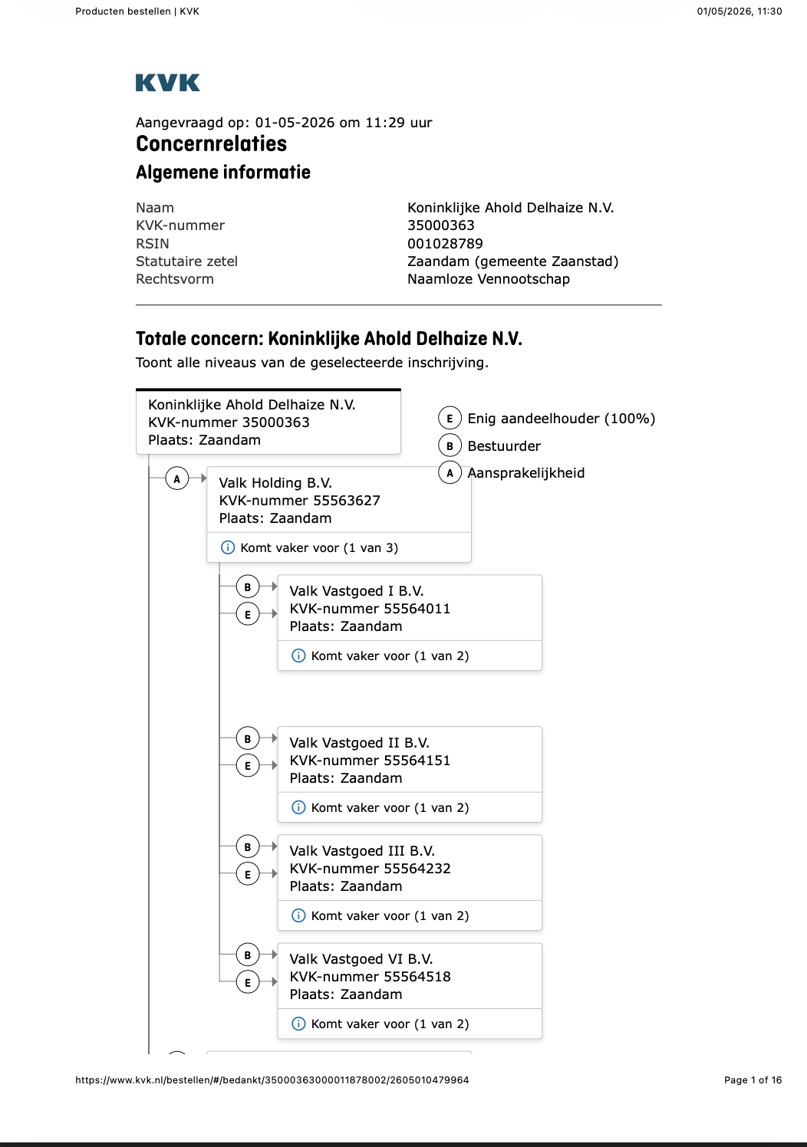
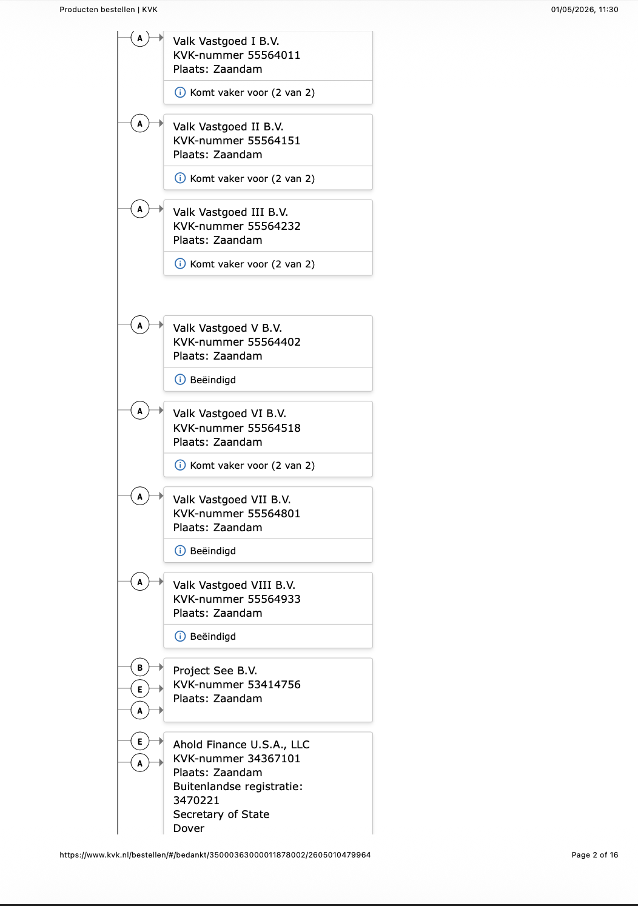
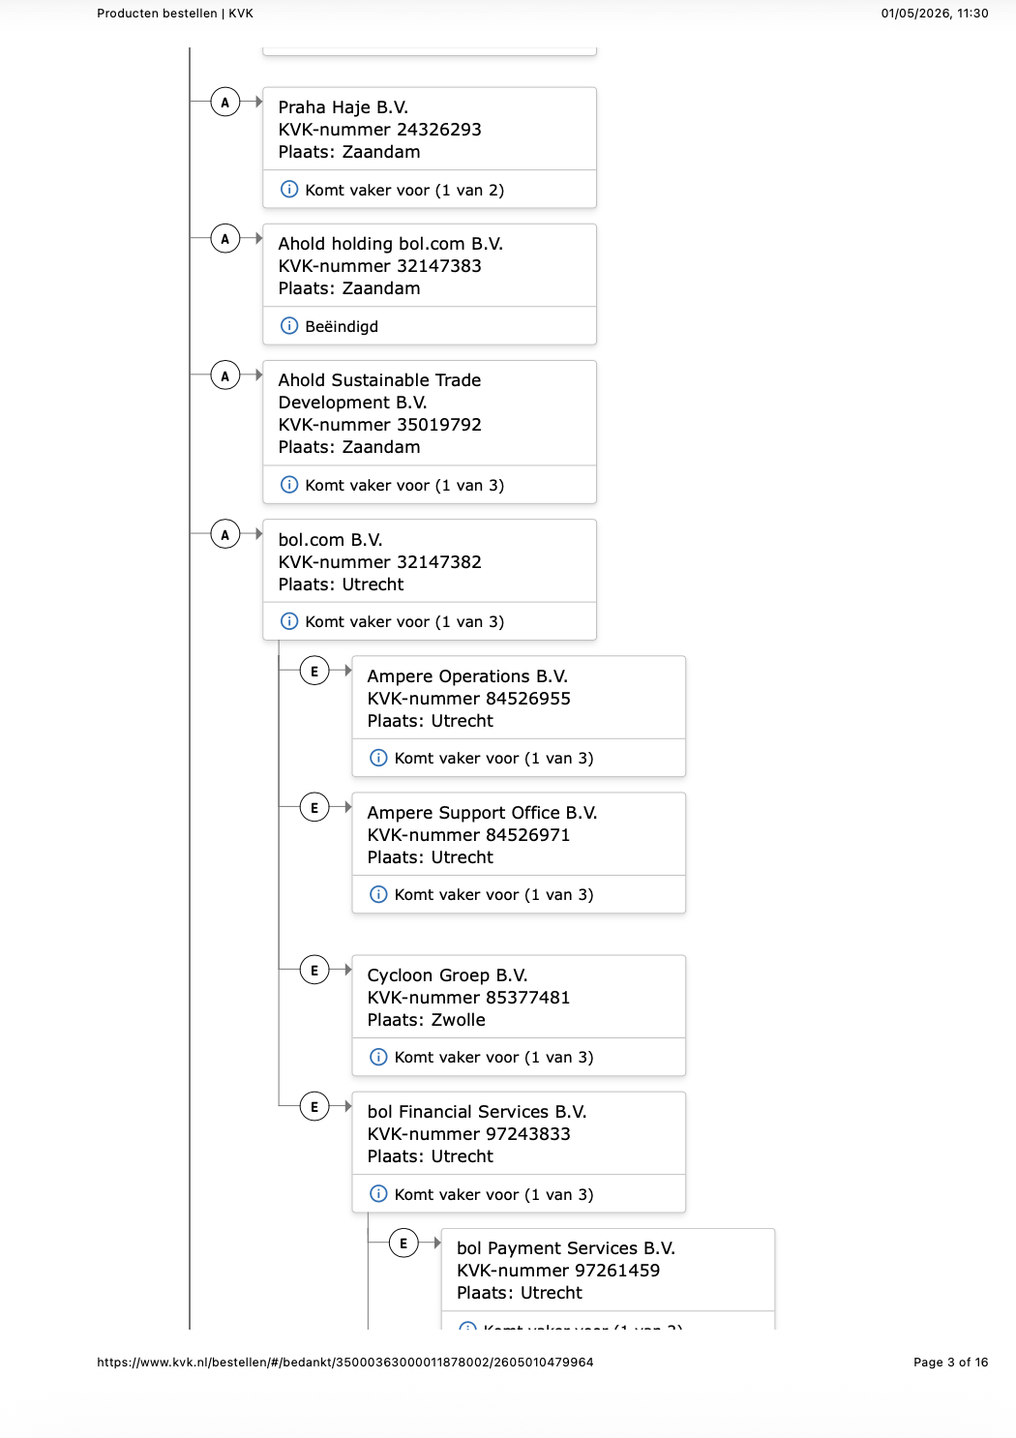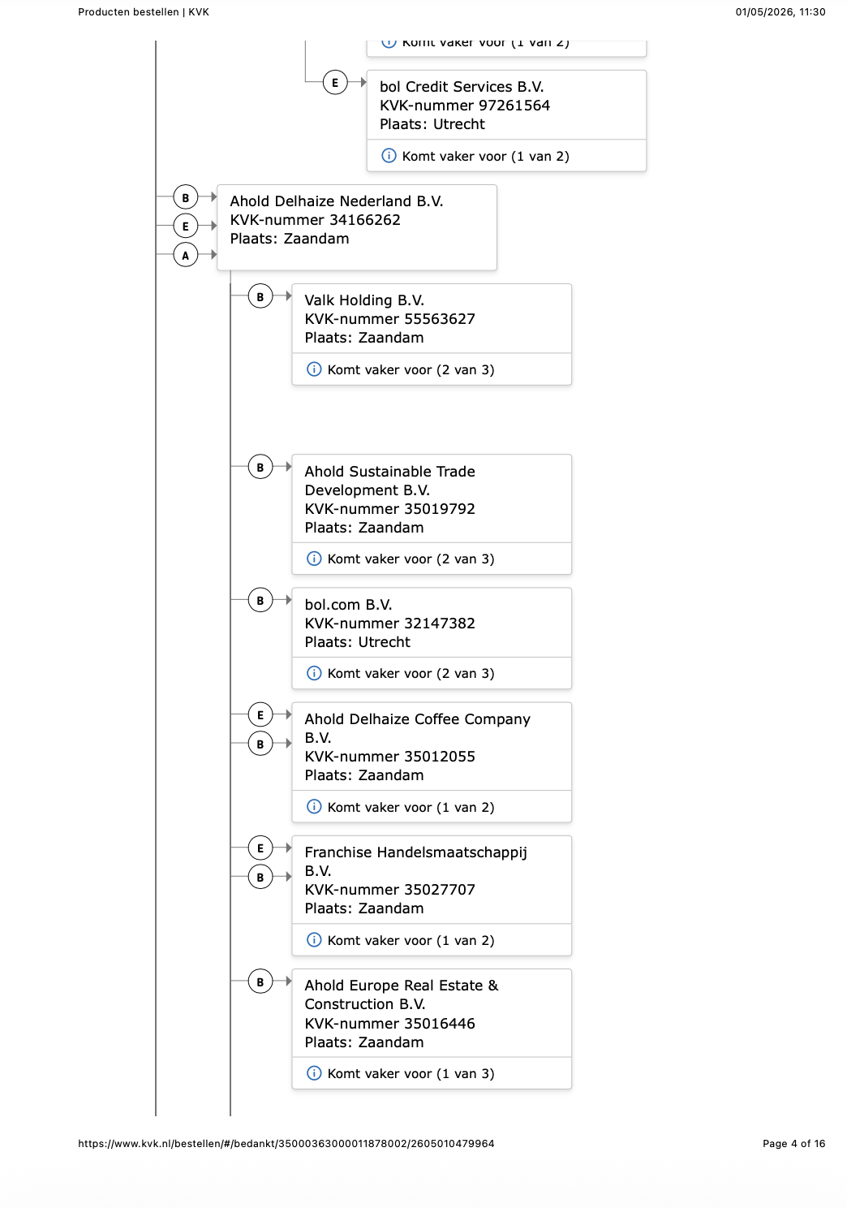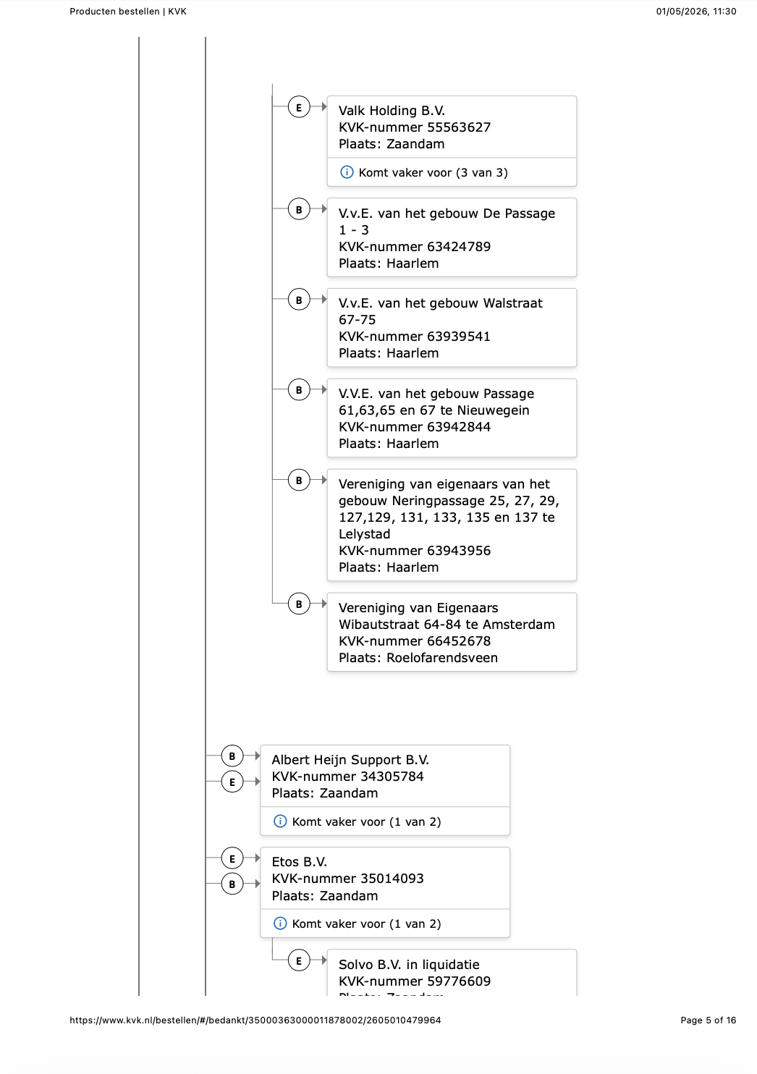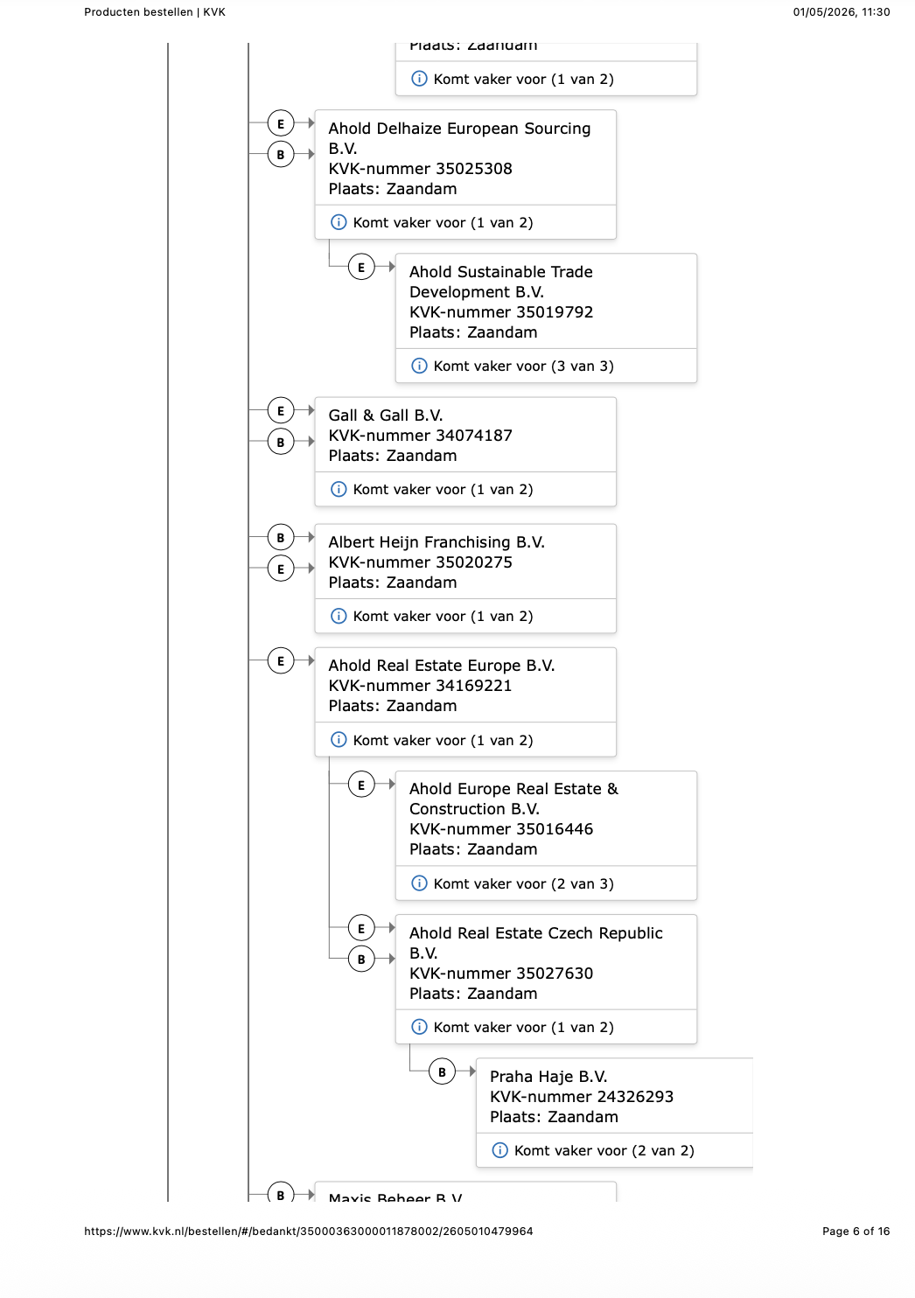

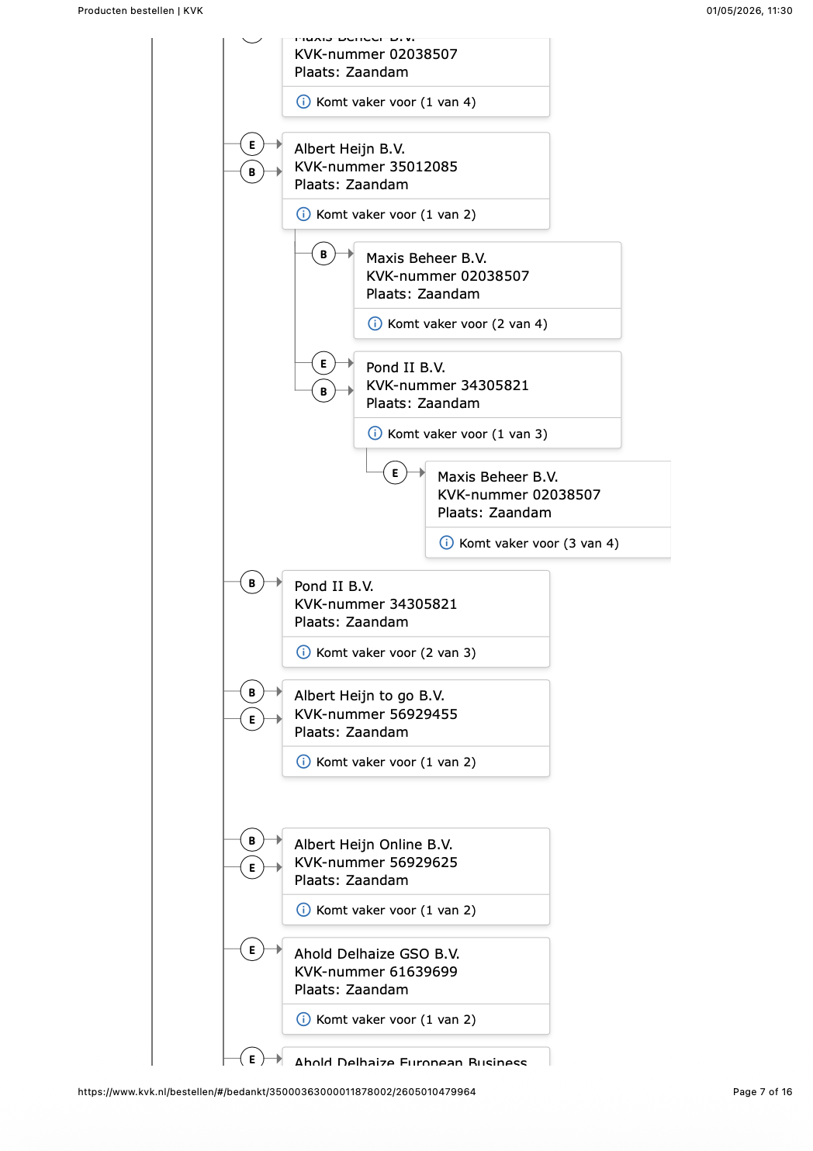

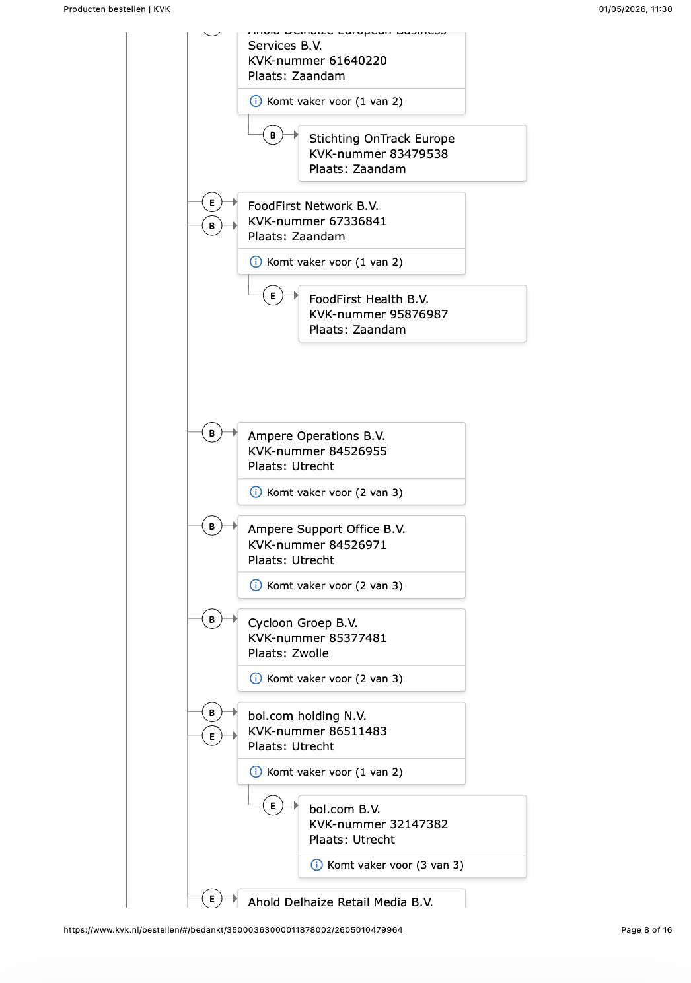

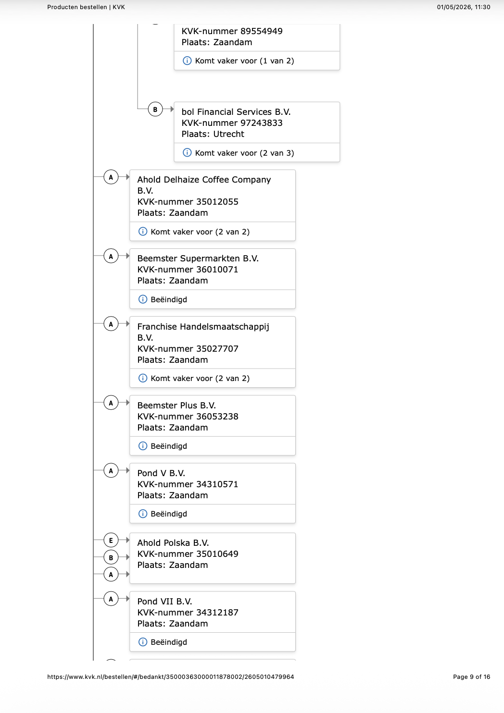

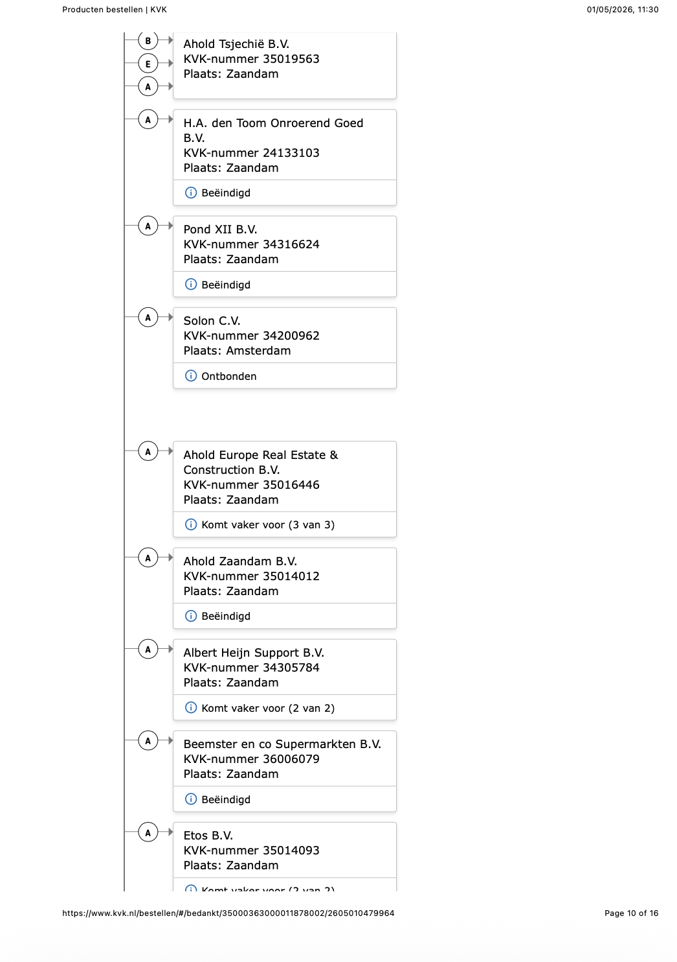

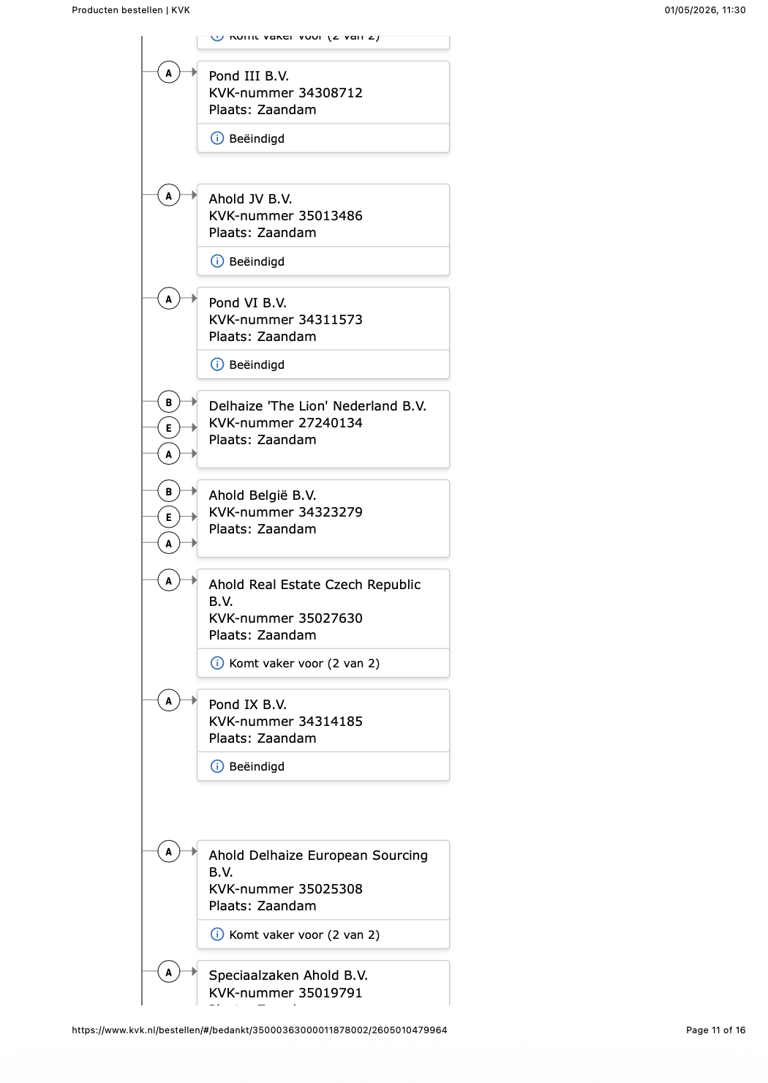

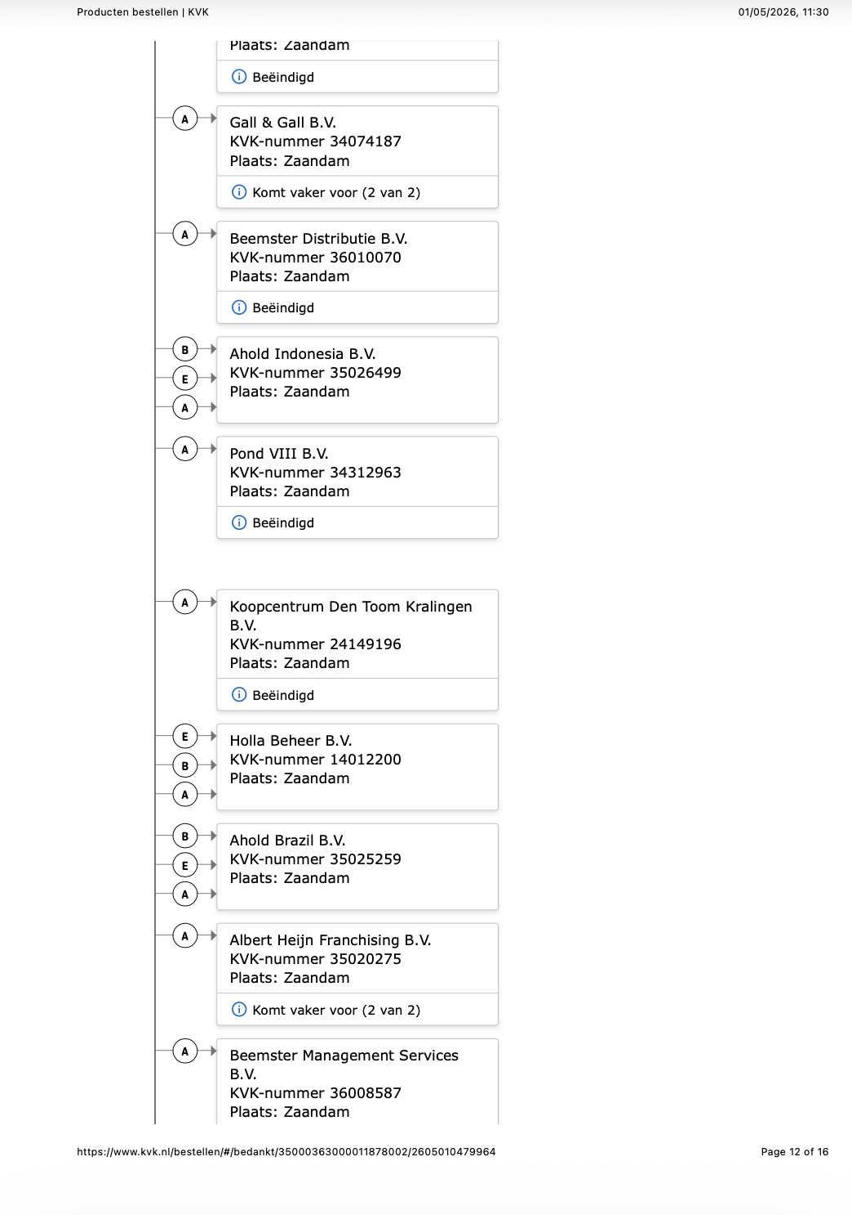

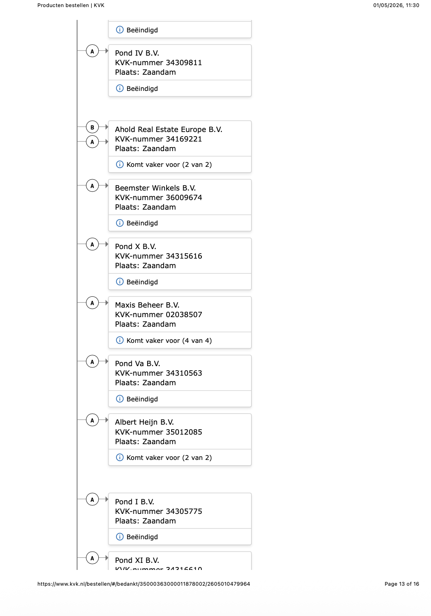
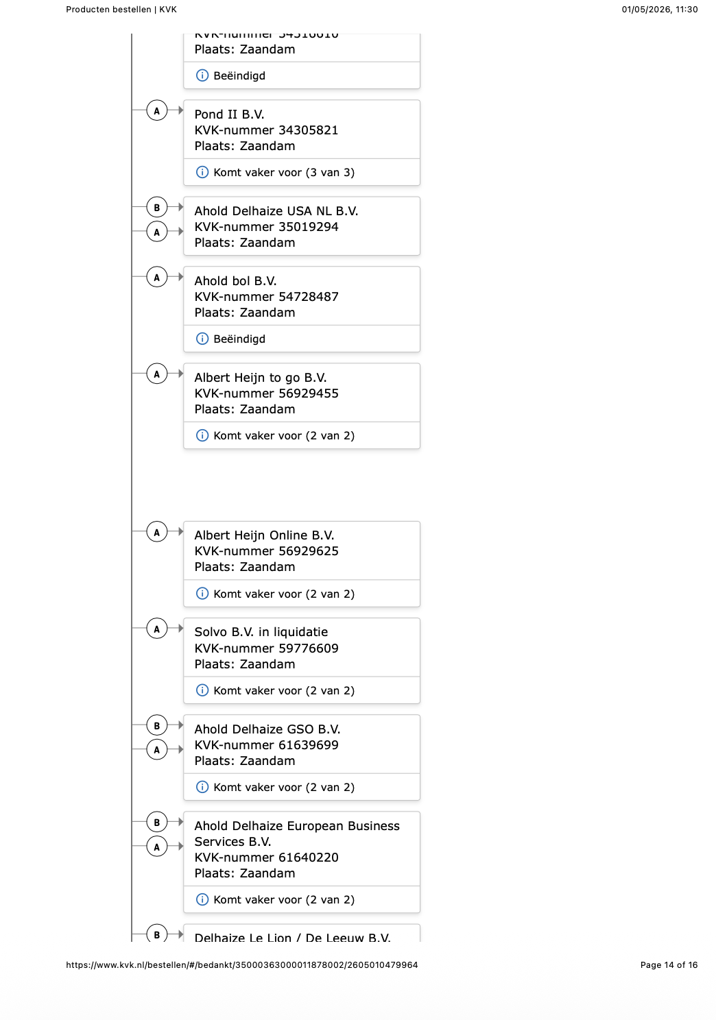

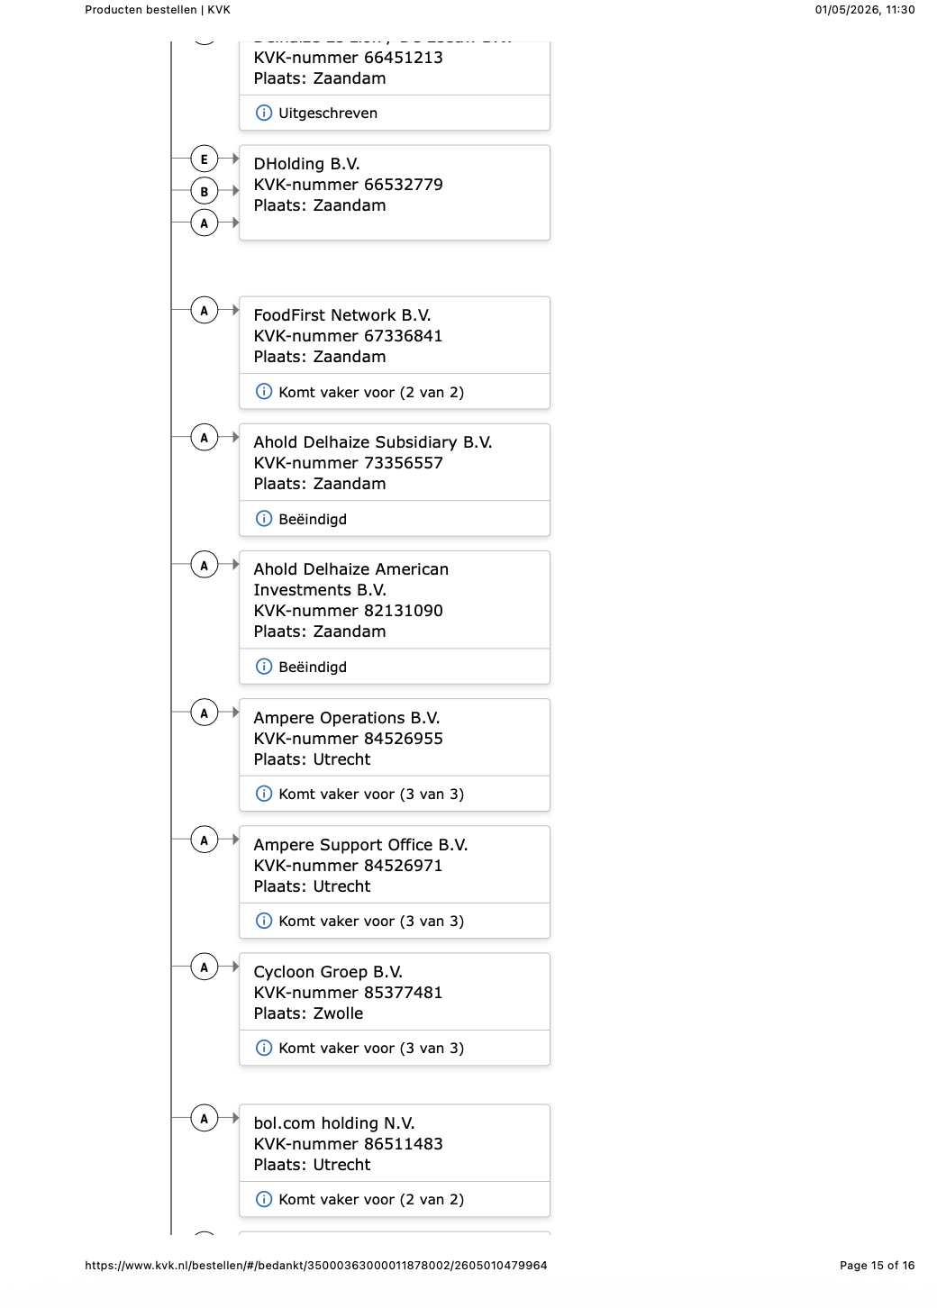

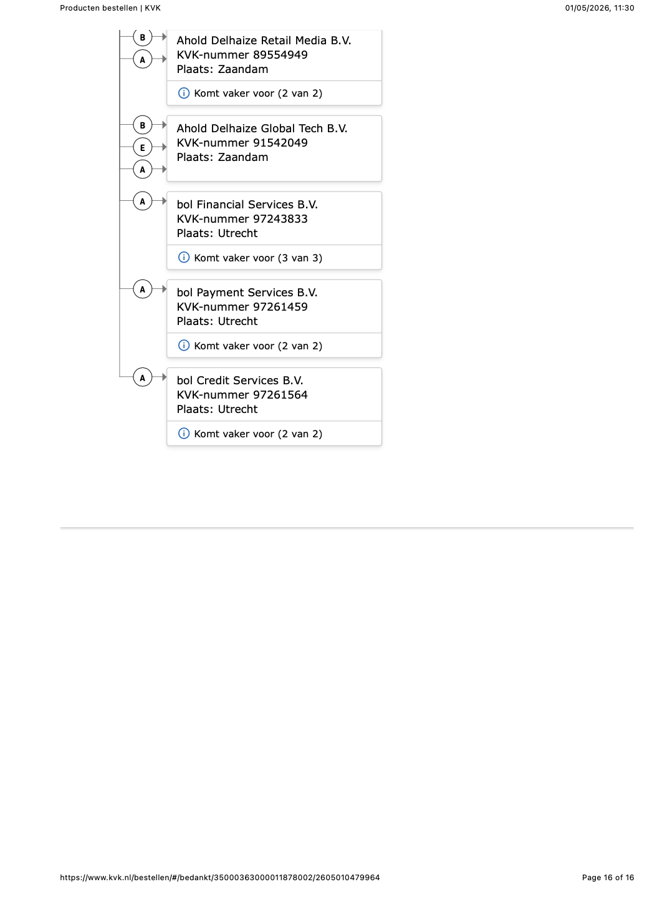

Appendix C3 – Concernrelaties Shell plc

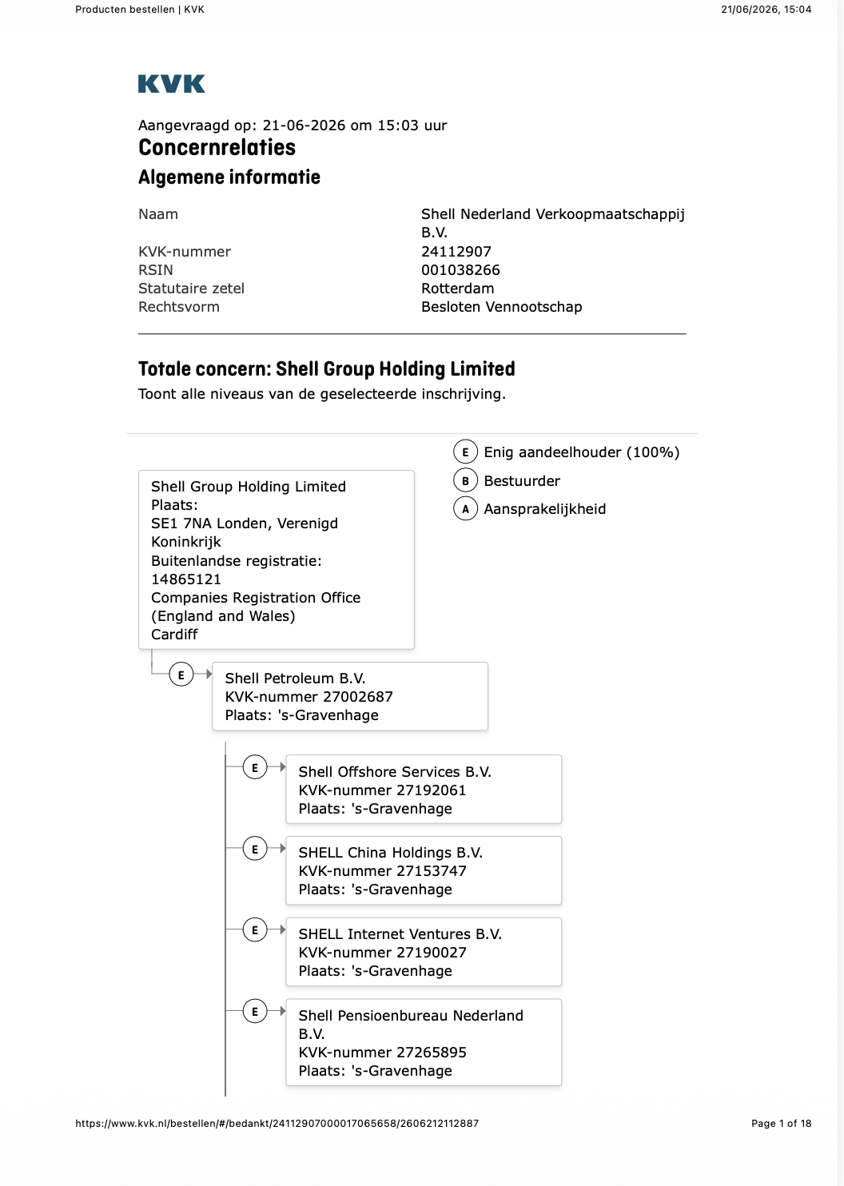
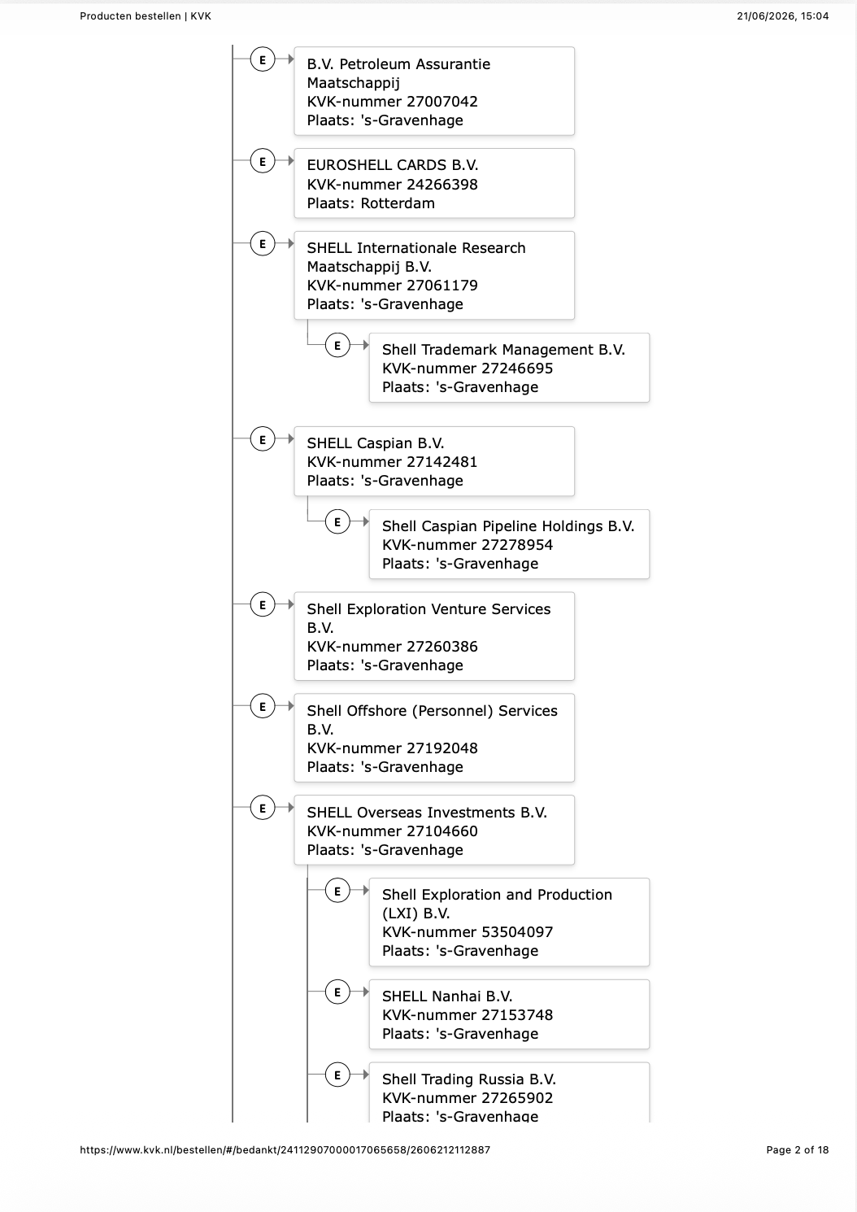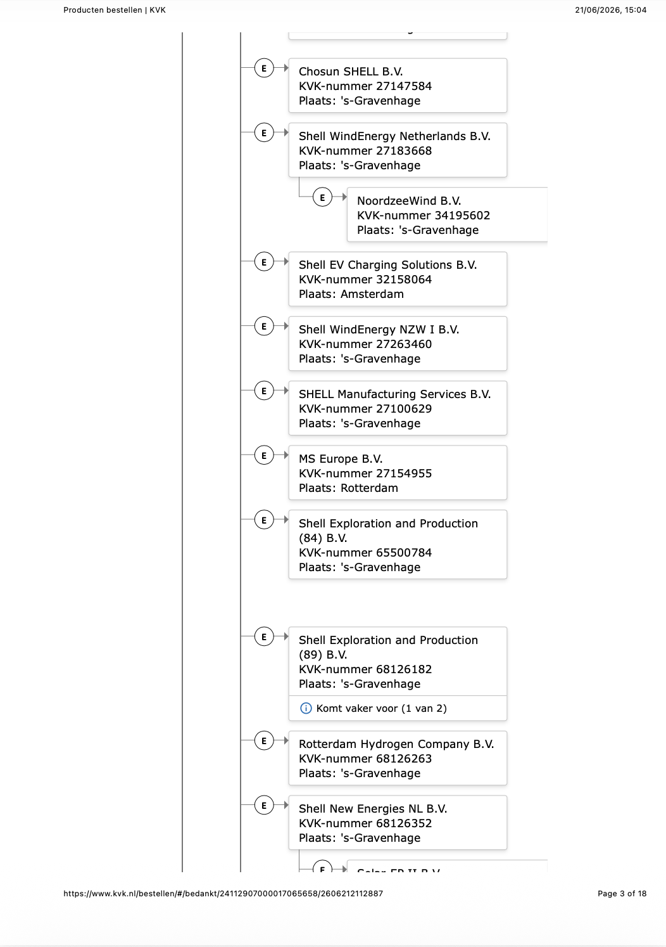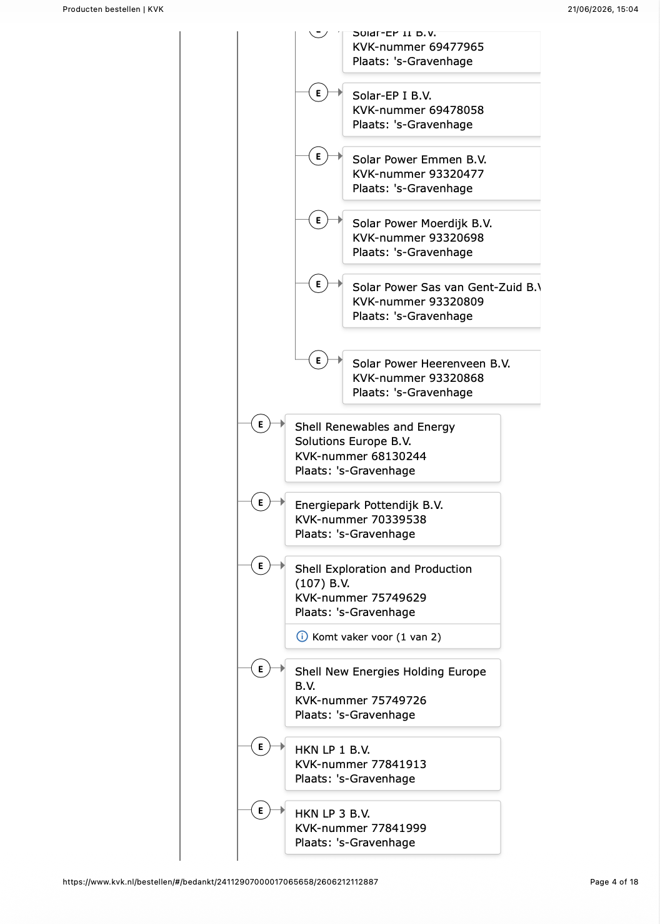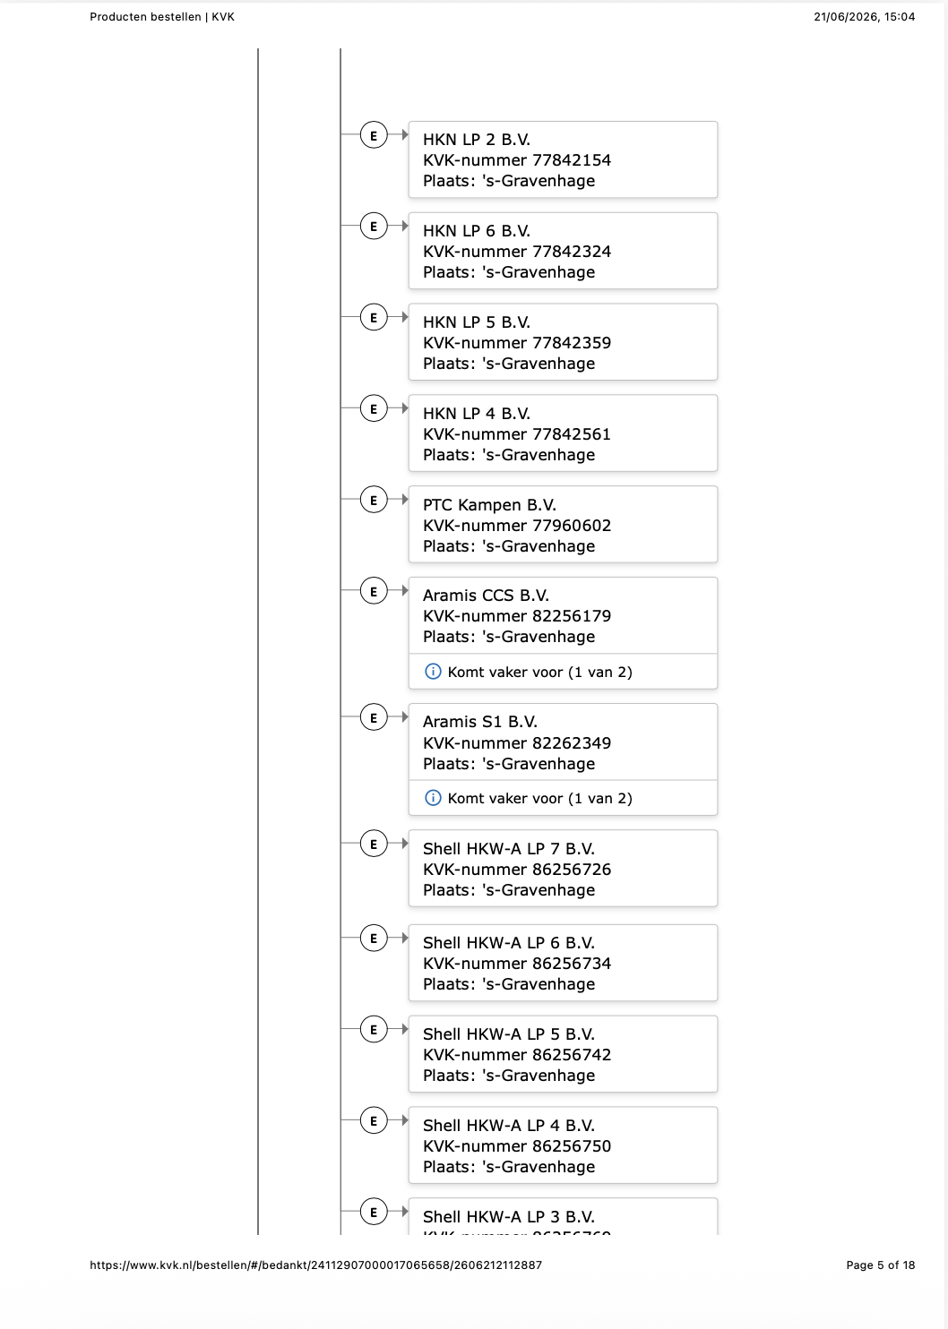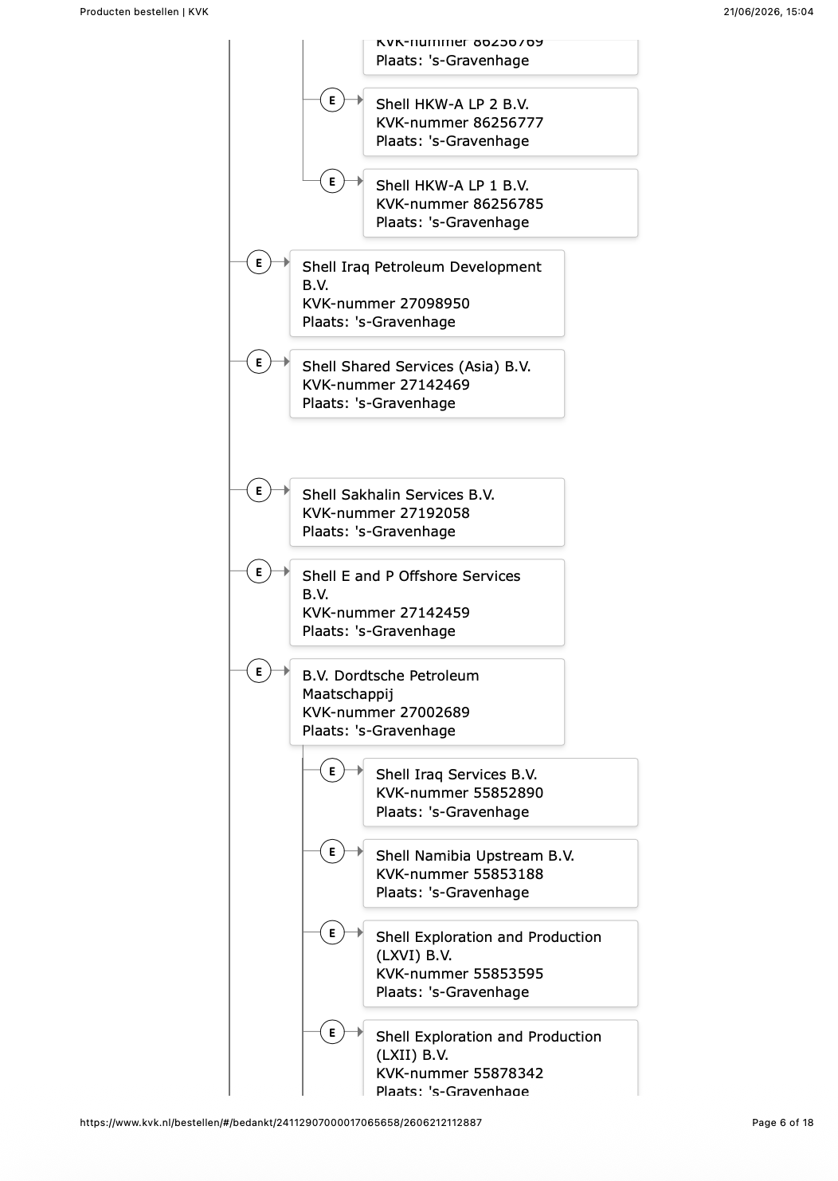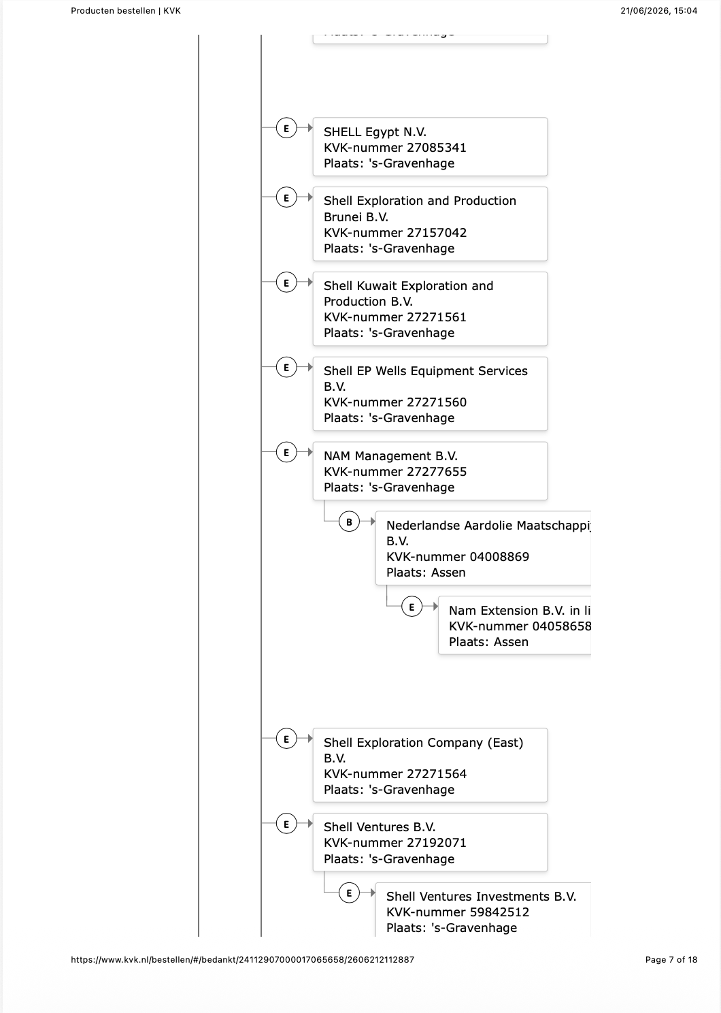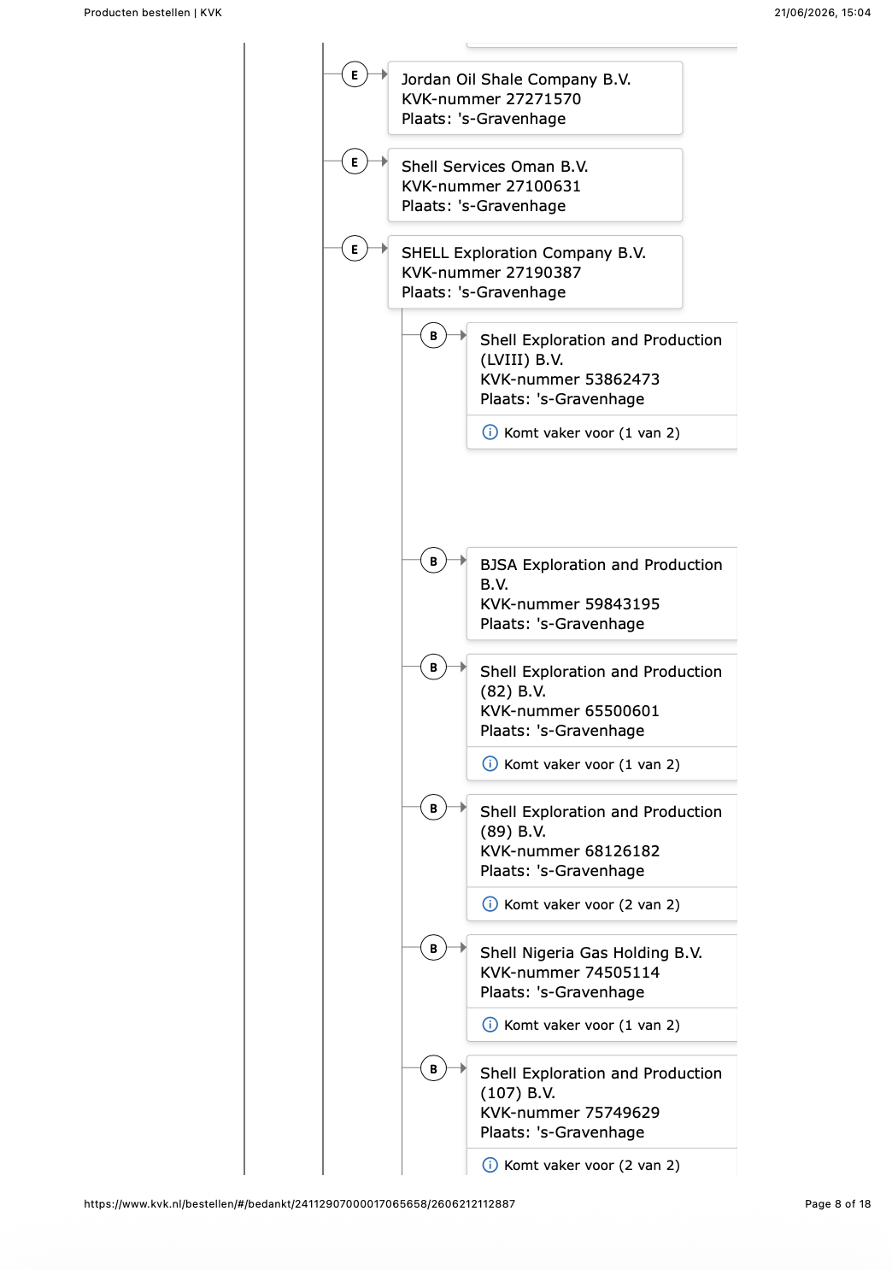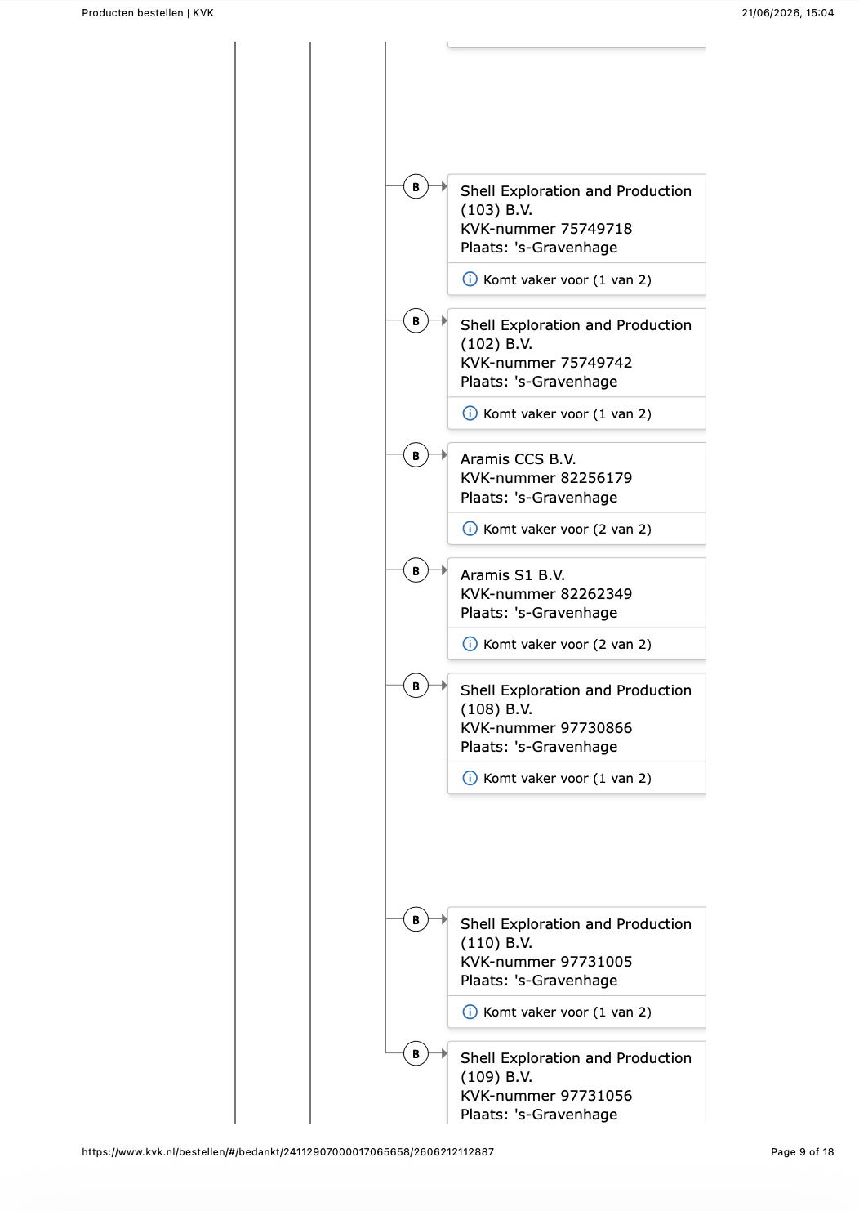
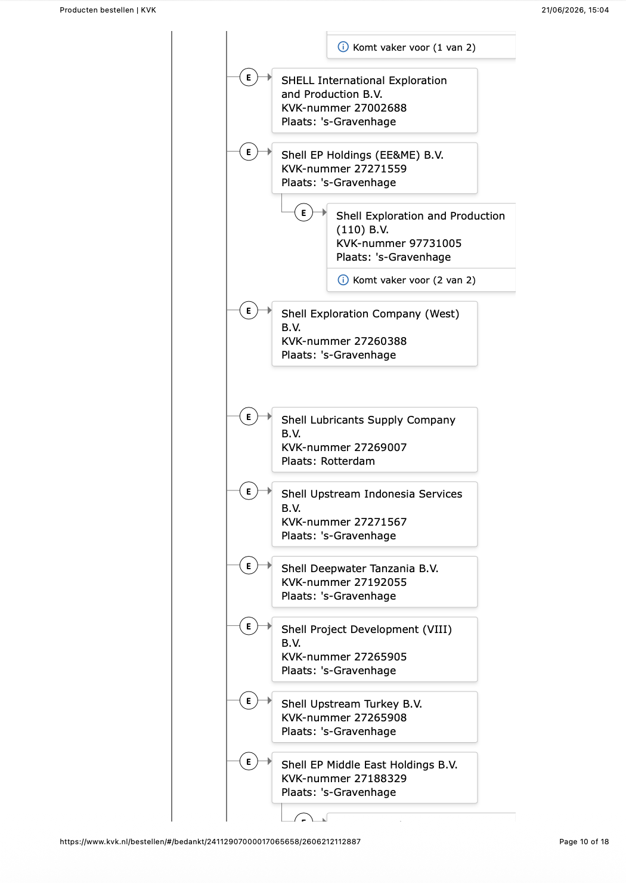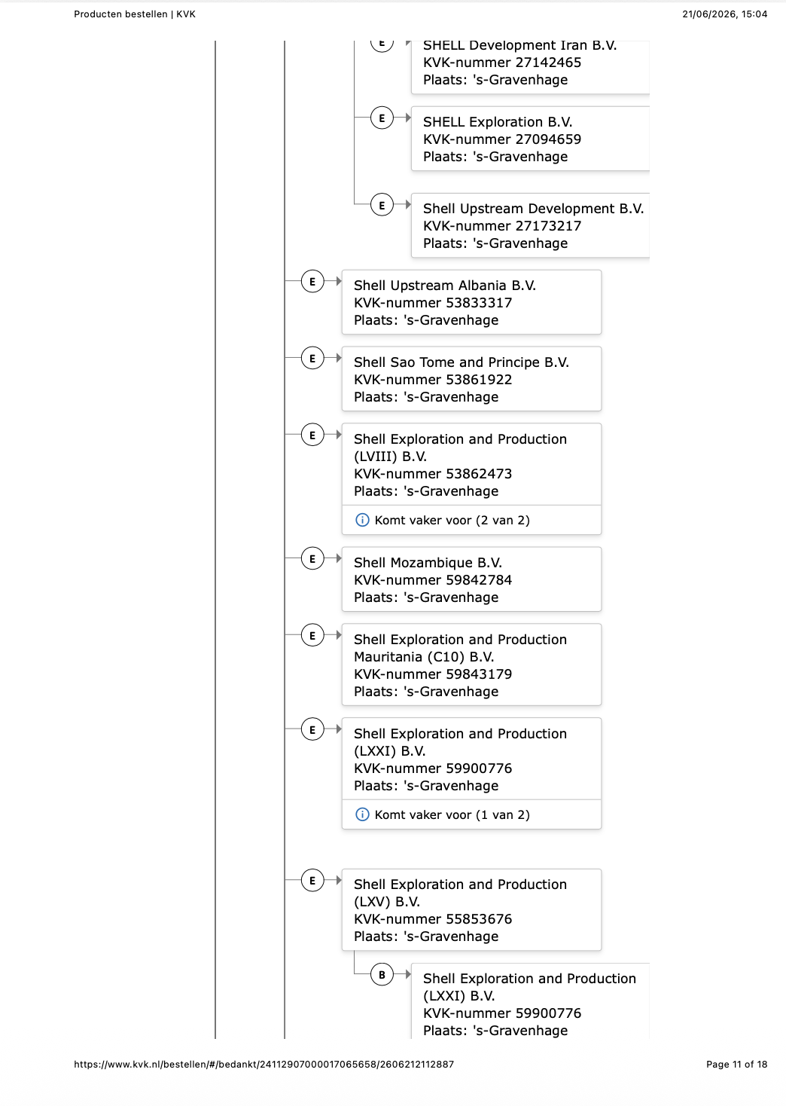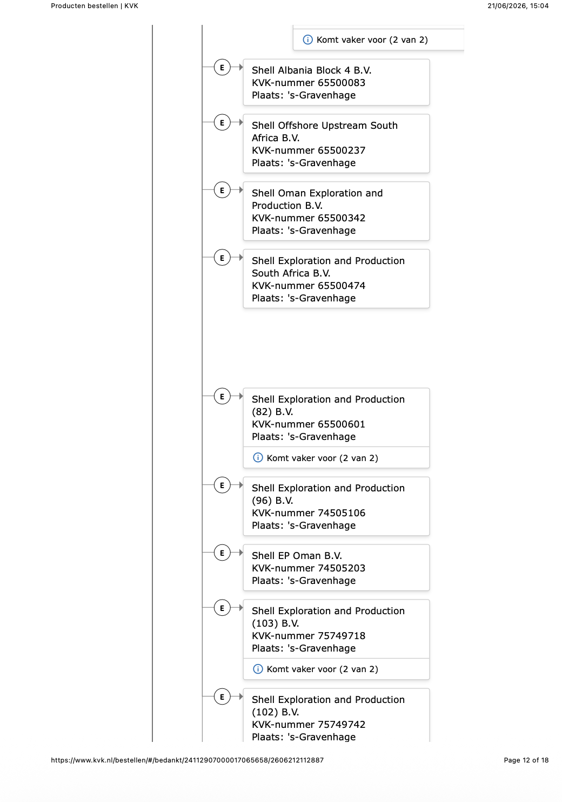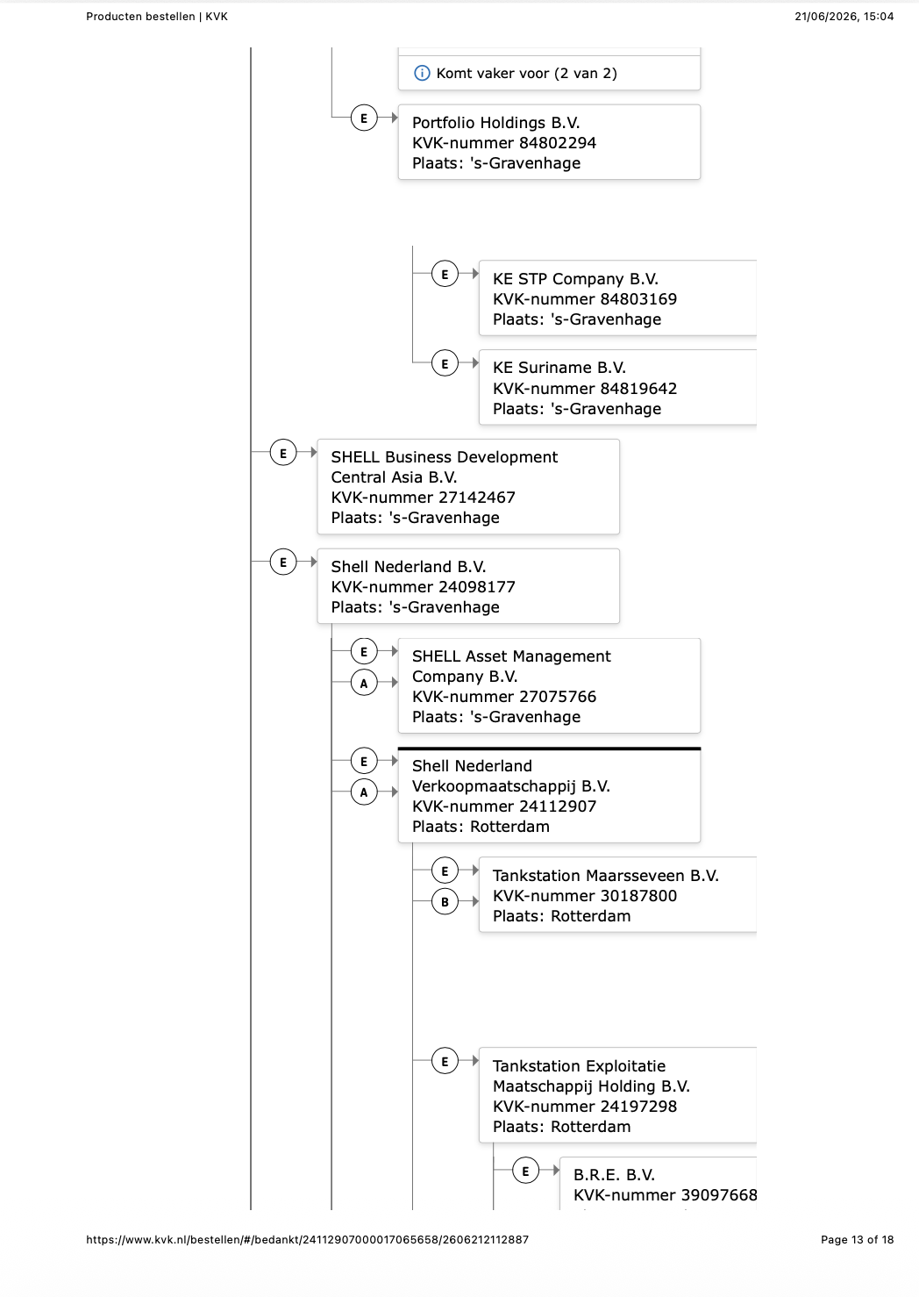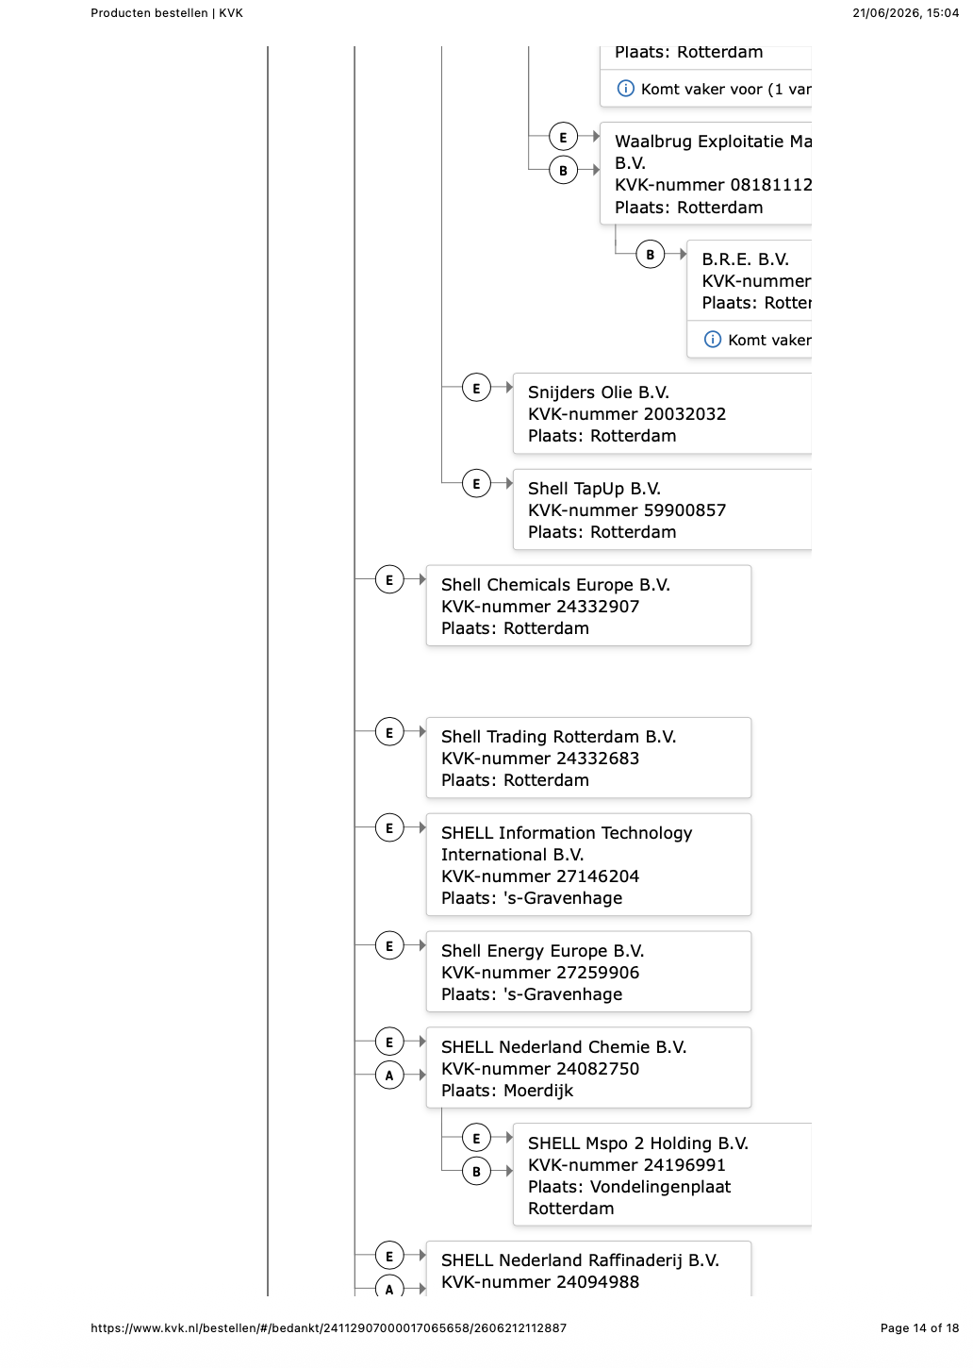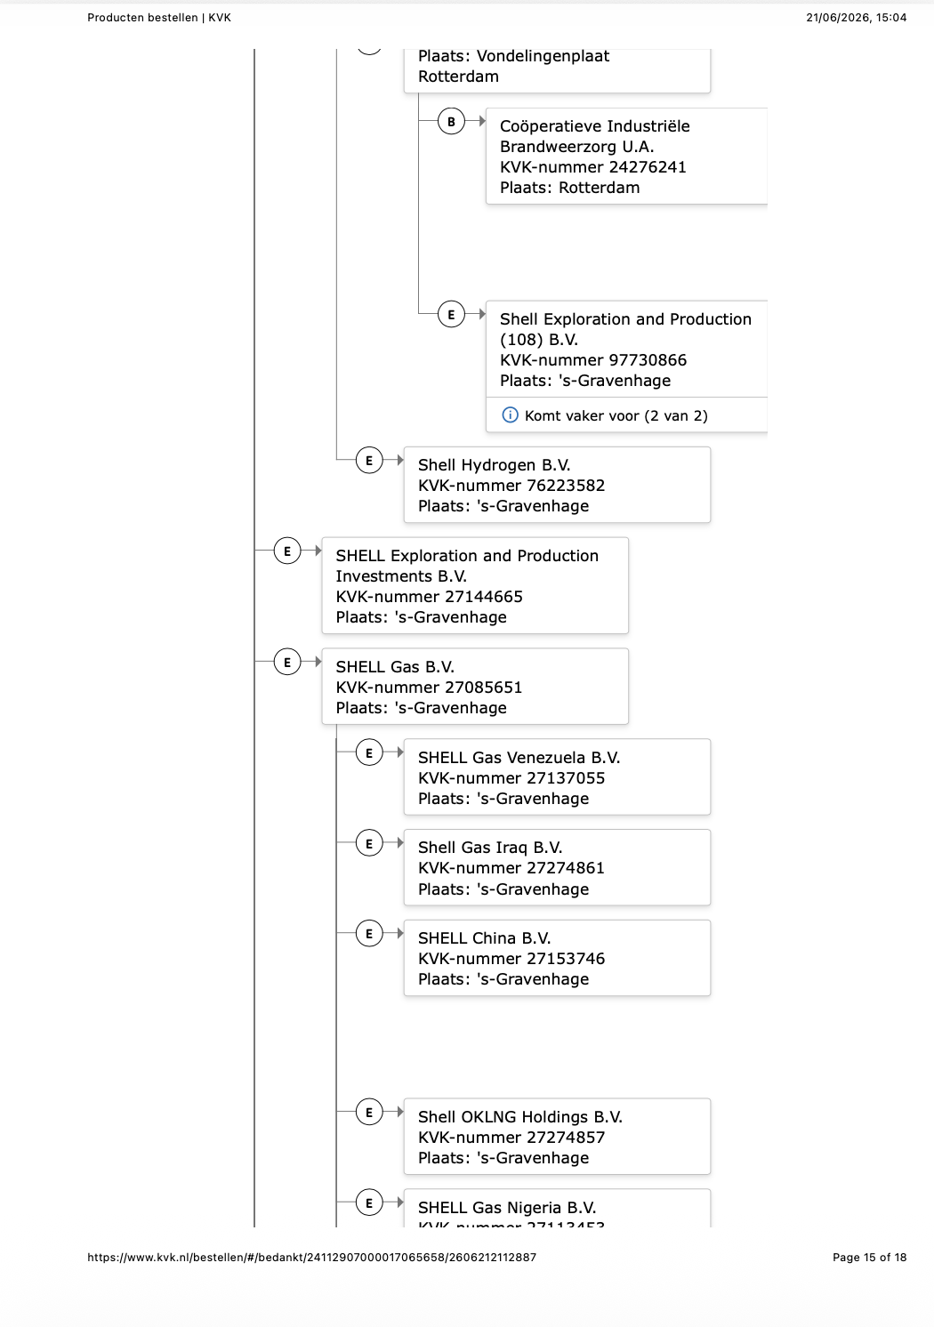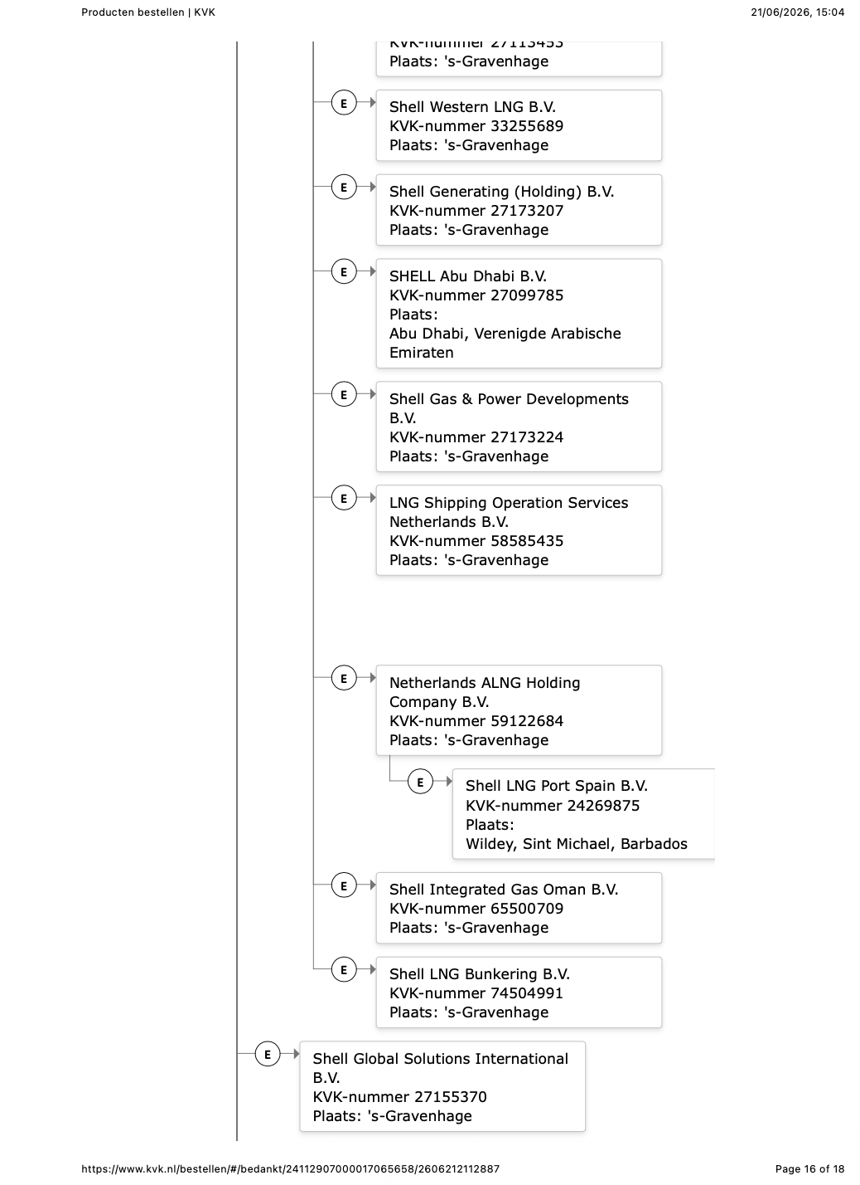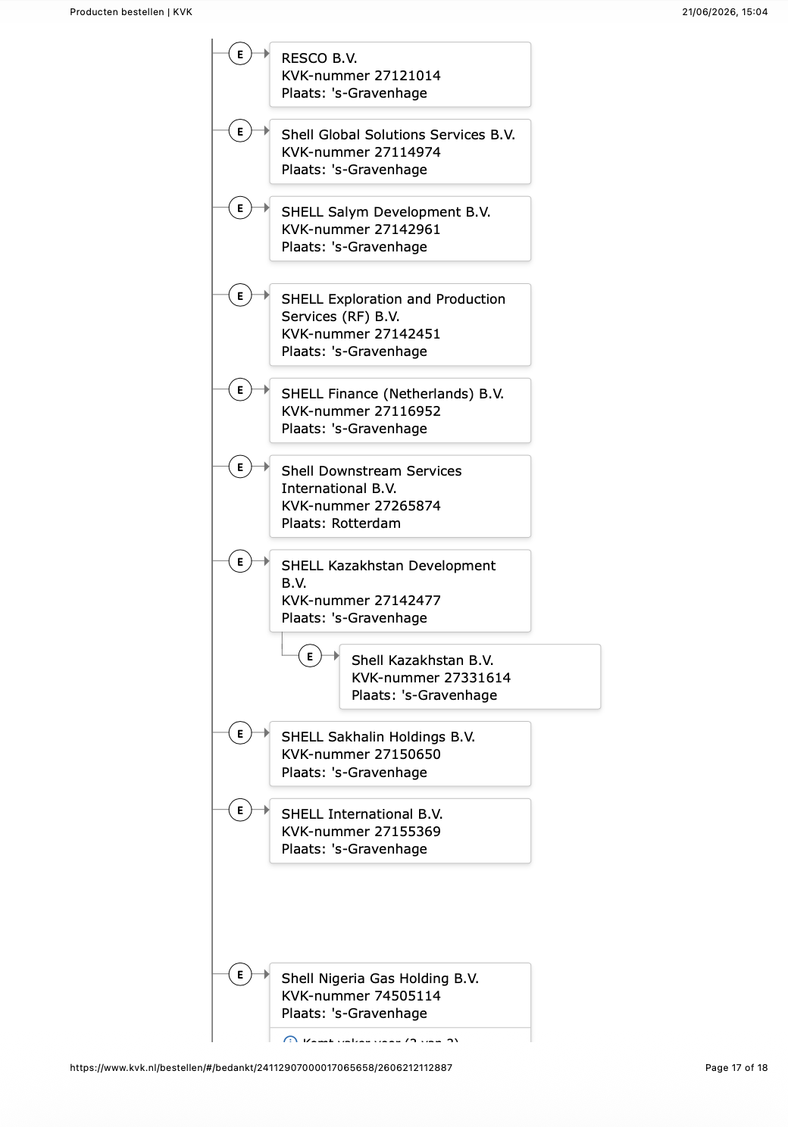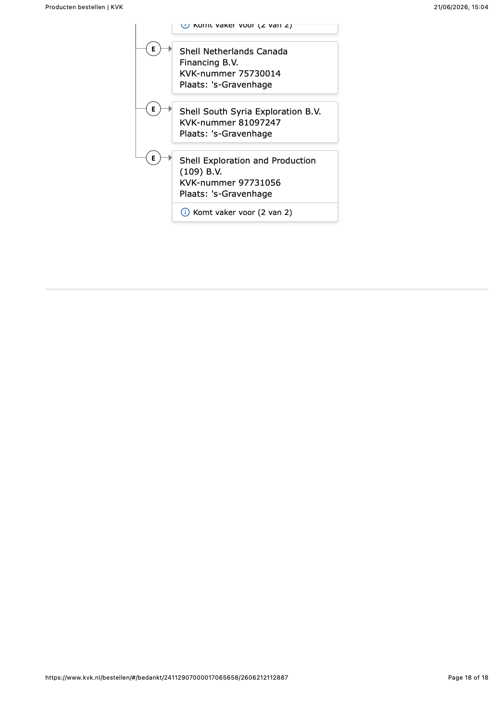

Hansmann, Kraakman, & Squire (2014), p. 11.
Fleckner (2020), pp. 233–234.
Gelderblom, de Jong, & Jonker (2013), p. 2.
Joint Stock Companies Act 1844 (UK); Limited Liability Act 1855 (UK); Companies Act 1862 (UK).
Salomon v A Salomon & Co Ltd [1897] AC 22 (HL), at 42.
Hansmann & Mattei, p. 438.
Hansmann & Kraakman (2000), p. 393.
Hansmann & Kraakman (2000), p. 440.
Hansmann, Kraakman, & Squire (2006), p. 1336.
Hansmann & Squire (2018), p. 4.
Iacobucci & Triantis (2007), p. 518.
Casey (2015), p. 2680.
Squire (2011), p. 606.
Pargendler (2024a), p. 4.
Hansmann & Kraakman (2000), p. 393.
See also Hansmann & Kraakman (2000); Hansmann & Squire (2018); Squire (2011); Casey (2015); Iacobucci & Triantis (2007); Pargendler (2024a, 2024b).
Vananroye, Van Hoe, & Lindemans (2018), p. 22.
Belenzon, Lee, & Patacconi (2023), p. 2897.
It should be noted that all KvK Concernrelaties documents are behind a paywall. During the screening these were not consulted due to time and monetary constraints.
Belenzon, Lee, & Patacconi (2023), p. 2890, n. 5.
Hansmann & Squire (2018), p. 24; see also Vananroye, Van Hoe, & Lindemans (2018), p. 39.
A014, p. 84.
Appendix C.
Jonkers (2019), p. 75.
Jonkers (2019), p. 80.
Squire (2018), p. 12.
Jonkers (2019), pp. 76–78.
Karapetian & Verstijlen (2018), p. 57.
Vananroye, Van Hoe, & Lindemans (2018), p. 22.
Gorton & Souleles (2007), p. 549.
Van Dooren (2021), p. 73.
Art. 2:403 lid 1 sub f BW jo. art. 6:7 BW; also see Van Dooren (2021), p. 199.
Art. 2:404 sub 3–5 BW.
HR 28 juni 2002, ECLI:NL:HR:2002:AE4663, NJ 2002/447 (Akzo Nobel/ING Bank), r.o. 3.4.3.
As Squire (2011), p. 606 observed in the 100 largest by-revenue US companies.
Nardo et al. (2008), pp. 96-97.
Tijssen (2009), pp. 44-45.
Nardo et al. (2008), pp. 96-97.
Appendix A lists every consulted source with date of consultation and URL.
A002.
Investegate. (2026, May 10). Keurig Dr Pepper acquires JDE Peet's and announces public offer. https://www.investegate.co.uk/.
A003.
9th of June 2026.
Appendix C.
S001, p. 52.
S001, p. 213.
S001, p. 213.
S001, Note 6, p. 284.
S001, Note 15, p. 288.
S001, Note 35, p. 278.
Albert Heijn B.V., Albert Heijn België NV/SA, Delhaize Le Lion / De Leeuw NV, Delhaize Luxembourg S.A., Alfa-Beta Vassilopoulos Single Member S.A., Delhaize Serbia d.o.o. Beograd, Mega Image SRL, Profi Rom Food SRL from FY2025, Albert Česká republika s.r.o., and bol.com B.V., Note 35.
Stop & Shop, Food Lion, The GIANT Company, Giant of Maryland, Hannaford Bros., idem.
S001, Note 35, p. 278.
S001, Note 6, p. 224.
S001, Note 22, p. 246.
S001, Note 22, p. 294.
S001, Note 22, p. 245.
S001, Note 34, p. 275.
S001, Note 35, p. 278.
S009-S015.
S015.
S001, p. 236; S005, Note 14, p. 204.
S001, Notes 12 and 13, p. 233.
S001, Note 33, p. 271.
S001, Note 36, p. 278.
Appendix B2.
S016, p. 231.
S016, p. 231.
S016, p. 291.
Appendix B3.
S017, p. 336.
S017, p. 454.
S017, p. 1.
Appendix B3.
S017, p. 40.
S017, p. 24.
S017, p. 24.
S017, p. 24.
S017, p. 340.
S017, p. 25.
Appendix B3.
S017, p. 75.
S021, USPTO records list Shell Trademark Management B.V. as the registered owner of the SHELL word-mark (Reg. No. 0286178, Serial No. 71312389) and of the Pecten device mark (e.g. Serial No. 78499816). Trademarkia. (n.d.). Shell Trademark Management B.V.: Owned trademarks. Retrieved June 23, 2026, from https://www.trademarkia.com/owners/Shell-Trademark-Management-BV
S017, p. 58.
S017, p. 73.

